**1960**

I had to smile when I read Dad’s words from sixty years ago giving me permission, and even encouragement, to do this letter project. (See the entry on Halloween.) In the early spring of this year, an accidental fertilization takes place. They call the baby “Pedro.” Dad’s excitement is palpable as he tells his Mother it is “an unexpected, but not unwelcome event for us.” There are all the usual activities in 1960, as well as the *un*usual and *un*authorized eating of candy bars and bananas. Dad disappoints his Mother, is confused by yokes, and hears Mom play drums for the first time. Mom scrubs the mildew, but makes Dad kill the water bugs. Lesle talks too much, and refuses to eat her sausage. Lisa vomits up her entire breakfast. And as the year draws to a close, the growing young family says goodbye to the Land of Ahs to seek their fortune in the Windy City.

**No Date – Sun 10:30 PM** – Dear Mother, I’ll start this tonight but won’t finish it till after I hear from you. Today and last night have been quite a bit colder but we didn’t get any of the snow which I presume fell on Western Kansas. I guess we came back the right day – if we’d come back on Thurs and been delayed we would have hit the New Years eve traffic and I guess it snowed some in Northwest Kansas by Friday. All in all we have been pretty fortunate these last three Christmas trips – this was the only time we had any snow at all. We were all glad for the visits and you know you’re welcome here any time.

Tomorrow night Ruth has to return some books at the library and I may go along and we’ll stop at a movie, providing we can get a baby-sitter, of course. Wed I want to go get my new license plates and then Lisa has her monthly check-up at the Drs. We may go to choir Thurs night. This morning Ruth went to s.s. and I to church. Lesle went to both and, as usual, came home quite tired. Two of the basses had to be out front for the instillation of officers so I was needed in the choir. If things get too demanding this spring I may not sing as much as in the past. There is a new man who is singing some, I think, so I won’t be needed as much.

For dinner we had some of the steaks that Mr. Laidig gave us. He also gave us a load of frozen meat 2 yrs ago at Christmas. Thanks so much for the coffee maker – it arrived yesterday. I’m sure we’ll use it and I imagine you’ll use the toaster. This afternoon I worked on my lab notebook and Ruth read. She and Lesle took a late afternoon walk and visited some of our s.s. class members who live in back of us. They have 3 girls who were thrilled by Lesle. We’ve been reading and studying this evening. Ruth has sprayed that old red wastebasket of mine with some Christmas gold paint. We’re starting doing some little jobs around the house as Ruth has circle 2 wks from Tues night.

Yesterday I worked at the building in the morning and we stayed home the rest of the day working and studying, as usual. We’ve finally got all the Christmas cards off. I sent one to Don Montgomery as we’ve sorta lost track of him. New Yrs day I stayed home and we took down the tree and everything. I listened to the football games in the afternoon. Ruth made candy and went to the Brownfields in the evening. Thurs morning I went to the building and came home for lunch. Ruth worked all day on her treasurer’s report for the s.s. class. I went back to the building after stopping by the bank and then came home early. We rushed for about 3 hrs and had the house cleaned up by the time Larry and Velda Brown and their 10 month old boy came. Ruth knew Velda at a church camp and they are members of our church. He is finishing his masters in social work here at the med. center. We talked and ate popcorn till about 1:00 AM.

Our trip a wk ago Wed to Oberlin was fine. We stopped in Sterling for lunch and I talked awhile with Olin Laughlen (one I worked for). We were there almost an hr as it takes that long to take care of everything. We then drove clear on to Phillipsburg without stopping. We had Pepsis and got some milk and Ruth drove on to Oberlin. It was dark by then and we got there about 6:30. They were just sitting down to supper when we arrived.

Fri morning we had our gift exchange – it was sure a big pile of gifts before they were passed out. Lesle got some blue tights from her Uncle John and a big carpet sweeper from her great-grandmother. She has a new little rocking horse from her grammy and also a big rag doll for her stroller. I had a white shirt from Eldon, a shirt from the Laidigs and another one at the Laidig gift exchange. I also had a couple of pairs of socks and a jewel box from John’s and $5 from Mr. Laidig. Lisa has some little toys. Ruth had some driving gloves and a pair of dress gloves from me. We had a record from John’s, and a picture frame, candy from the Musgraves. Ruth had a slip from Eldons and a dress from her father and a jewelry box at the gift exchange. She had a couple of pairs of ear-rings also. You see we did quite well. There were some other small items. Lisa some red and white stripped pajamas. Lesle had a sewing machine.

Fri we went out to Uncle Floyd’s. He lives on the old Laidig homeplace and they have a daughter at K State plus two married ones who were at the dinner with their families. We had a big dinner and the gift exchange. There were about 25 there. We stayed till 4:30 or so and ate a late supper back at the Laidigs. The farm is 18 miles NE of Oberlin. I read all of your clippings while there (2 or 3 months) and caught up on some reading. Sun morning I walked to Mr. L’s s.s. class (only 6-8 there as had snowed the evening before) and then stayed for church. Mrs. L couldn’t make it and Ruth brought Lisa to church and left Lesle in the nursery. Uncle Earl (Mr. L’s dentist brother) and his wife were over for dinner and we watched the football game on TV. I watched enough TV to last me for some time while we were there. I had $19 worth done on the car while it was there. After it snowed on Sat and there were the blizzard warnings for North Central Kansas on Sun we knew we couldn’t make it on Mon. Two of the Musgrave boys and I went to Rotary with Mr. L Tues noon. That was about all we did of any significance.

Tues afternoon we visited some of Ruth’s friends as we did one other evening. We were glad to have your letter yesterday. (Its now Tues.) We went to the show last night and Ruth’s getting ready to mail this, stop at library and go by the Brownfields. Hope all are OK and tell Aunt Clara, M.J., Bill, Jimmy and Uncle Clyde hello. Thanks again to everyone for the Christmas gifts.

**1-18-60** (I don’t think this date is correct) **– Tues 11:25 PM –** As usual I’m late getting this started as we seem to be as busy as usual. Be sure and let Aunt Clara read this if we don’t get a separate note to her before she leaves. The last 2 or 3 days have been foggy, rainy and extremely warm for this time of year. I believe it set a new record for this time of year. We can use some relief on our gas bill as it ran $13 for Dec even with the time we were gone. The highest it ran at the other house was $18 and we thought that was very high and due to the loose windows etc. As you remember, this house is just cement blocks and the walls offer little insulation and get extremely cold. Ruth has spent many hours the last few days cleaning off dirty mildew that has accumulated on the walls etc. I told you about that before, I believe. Ruth is also gradually starting the cleaning for her circle next Tues evening. It will be somewhat crowded but she likes to have them and we’ll probably be gone next year.

Our graduate course scheduled for yesterday evening was postponed till this afternoon as the guest lecturer’s plane from Canada was delayed by the foggy weather. This evening I got a bolt to fix the stroller so the “women” can all go for a walk and ride tomorrow if its not much cooler. Ruth went to the Brownfields a little later on this evening. She has already used the coffee maker twice when Mrs. B has stopped by here. I’m sure we’ll use it more than a waffle iron. She’ll, of course, use it for next Tues night. We were home yesterday evening and I listened to the KU basketball game.

Sun we all 4 went to s.s. and church. The Dr. had said to wait till Lisa was about 4 months old because of those colds she had. I have a touch tonight so hope we’re not starting on a round. We sang in the choir as usual. I definitely will start missing rehersals as I need all the time I can muster for study. If I work very hard I can probably make it by June. I promised Dr. Walaszek that if there were some problems left over that I would stay around a few months to finish them up. He talked to that man in Chicago, where I might go, over the holidays and I guess I can go there for a yr or two if I want too. I’ll try to see him when I’m there in April and we’ll look things over. We have several friends in Chicago.

Hugh Burford was over for dinner Sun as he had to leave his wife and little boy in Mississippi. He was delayed in leaving here at Christmas time since she was sick and they found out she had viral hepatitis when they got there. She is a nurse, you know. She’ll return about Feb 1st with one of their parents. Hugh stayed awhile after dinner and we rested and read the rest of the day.

Sat morning I worked at the building. Ruth and Lesle went to library and shopping later in the afternoon. We were home the rest of the day. Last Fri night Ruth went to the Brownfields and I stayed home Thurs night from choir while Ruth went. Wed morning we all went down to get the license tag and it took all morning because of the crowd. Ruth had to go as the car is in her name and we wanted to change the registration. We were all exhausted by noon and Lisa had a 12:00 Drs. appointment. Ruth took her and I fed Lesle and then went back to pick up the tags (we didn’t have time to wait for them) and then back to the building. Lisa weighs 13 lbs 3 oz 24¾” high and is now eating meat and eggs. She sure likes to stand – with help, of course. Lesle had a real fussy time at supper tonight and had to leave the table. Her emotions sure vary from one time to the next. I guess she is usually tired or hungry, though, when she’s upset. We were glad to have your letter yesterday. Tell M.J., Bill, Jimmy, Aunt Clara, Uncle Clyde all hello.

**1-19-60 – Mon 12:15 AM -** We’re up a little later tonight than usual so I’ll get this started. Ruth is waxing the floor of the bedroom (at 12:15 AM!) so I can’t get in there to go to bed. As you’ll remember, tomorrow night is the circle meeting here at our house. As usual, much of the cleaning has to be left to the last day because of the children, etc. Because of the snow, Ruth doesn’t think she’ll have more than 10 come. That’s a nice number for our living room.

We were glad to have your birthday card to Ruth today. Ruth says thank you for the silver. She said she needed it for tomorrow night. I’m going to try and come home a little early tomorrow night so I can help get the girls in bed before the women come. I’ll go back to the library or building in the evening. If the turnpike is not too slick Wed morning we plan to drive to Lawrence so Ruth can get approval on her courses that she plans to take at K.C., Mo. Jr. College. Unless you teach 2 out of 3 years after you graduate you have to take several hrs to keep your certificate in force. She plans to take them in night school, probably Mon and Wed. We’ll have to hire a regular babysitter, I guess. The last night we had a baby sitter she apparently ate one candy bar and took 3 of them with her – none of them had been offered to her. We usually offer them a Pepsi but the last few times they’ve also been eating bananas that were on the table – not offered either. We’ll tell them about it next time.

Ruth will probably go to choir this Thurs night and I’ll work. Our house is so poorly insulated that the snow is practically gone off the roof (none of the neighbors’ are gone) and huge icicles have formed. As I mentioned before, it looks like our gas bill may run as high as it did at the other place. In light of the heating problem and the mildew on the walls I can see why the people moved out. I guess the people who moved into the house on Shawnee Rd after we left moved out the other day. They had lived there less than 4 months, but you can understand why they probably left so soon. I imagine Mr. Denny is in Florida now.

The Brownfields all stopped by this morning and helped Ruth celebrate her birthday. Lorraine gave Ruth a black corduroy hood she had made. I have promised Ruth several household items for her birthday but we haven’t had time to get them yet.

A fellow who is finishing up at the University of Michigan was here today and gave one of the lectures during the graduate course time this evening. I guess he is being offered a job but he comes with such high recommendations that he probably has several offers. Dr. Peters has been trying for some time to get a new staff member but has not had much luck.

Dr. Walaszek has offered to pay my way to Chicago for a day to talk to the fellow at the University of Illinois where I might go. I’m sure the work would be quite satisfactory, the only problem is that to get decent housing for two children, etc. one would probably have to commute up to an hour. If it were on a bus or train it wouldn’t be too bad if you could get reading done, etc. The reason I’d go up for a day now is because I’m going to apply for a Public Health (government) post-doctoral fellowship for 1-2 years. It should pay at least $5500 to $6000 with two dependents and part of it is tax free. We want to apply for it before we’d be there in April. If I shouldn’t get it the fellow at Chicago would probably have some money available. I’ve written Ted Addleman in Oberlin and told him that I should be available for some time next summer. After I hear from him, one way or the other, I’ll try to line up some Hutchinson work. We should get about $100 back on our income tax. Sun morning it was snowing, I had a cold, as did Lisa and Lesle so we all stayed home. Ruth has a touch also, and mine is better today, as are the girls. That is the first time we’ve all missed church in about a yr (car wouldn’t start a yr ago).

It is to get down to 5 degrees tonight and 0 tomorrow night. Our car starts much better with our new battery which I got 3 months ago. It was nice Sun to just relax without having any place to go and we got caught up on some reading and studying. Ruth gave me a haircut. We didn’t let Lesle go out in the snow because of her cold. It was a major occasion this past week when for the first time, Lesle made real use of her little stool in the bathroom. It had only been a week or two before that she had been willing to sit on the stool without her panties.

Last Sat morning I worked at the building. Ruth hired a baby sitter in the morning and took Lesle out for some new shoes and got some material for matching dresses for the girls. In the afternoon after Lesle was asleep Ruth went for groceries. In the evening I took Ruth for a birthday dinner at a nice cafeteria and we then went to see Porgy and Bess (movie). Fri night Ruth went to Brownfields and to choir on Thurs while I studied. I guess that’s all we’ve done since I wrote last. Is Aunt Clara gone now? Is her address the Baker in Mineral wells? Tell M.J., Bill, Jimmy and Uncle Clyde. Ruth had a card from M.J. Mom adds: Lesle’s saying “hold,” so this will be a brief note. I think everything will be in good shape for tonight. I’m doing the last minute cleaning now, the salad is made, etc. Now if the girls will just go to bed as early as I hope they will. Thank you for the salad fork. As Carroll said, it’s just what I need for tonight – now I know I won’t have to borrow. Better get this out now.

**1-24-60 – Sun 5:15 PM -** I’m holding Lisa after having fed her some solids. She’ll have a bottle before she goes to bed around 7:00 PM. Ruth and Lesle went for a walk and have probably stopped somewhere to see somebody. After several days of bitter cold weather, and with the lows near zero, it warmed up to freezing this afternoon. None of our colds got real bad but we all still have traces and Lisa usually wakes up in the morning with a cough. Lesle has been restless at night, and was up a time or two last night I believe. Lisa is now sleeping in the bedroom with Lesle and that may be part of the reason. We have used the vaporizer a lot at night as it seems to help some.

I stayed home with the girls this morning and Ruth went to s.s. Ruth was supposed to help with the babies during church but she has a sore throat so she thought it best not to. She traded off and helped clean up after the “coffee” which our class and another had together so all could meet the new prospective assistant minister, his wife and baby (Lisa’s age). They’re young, of course, and he will be available this June, after graduation. He is top man in his class at McCormack Seminary in Chicago (one of the top Presbyterian seminaries). We have been home the rest of today reading, studying as usual.

Tomorrow night is the graduate course and Wed noon Ruth would like to go to Women’s Association at the church since her circle is sewing. We had a “scare” yesterday morning when (Ruth and Lesle are now home they stopped at a neighbors) the washer wouldn’t start. It started later and apparently was just cold.

Lisa is not as “good” since the Christmas vacation. In other words, she does a lot more crying and most of the time for no apparent reason. She is teething (I had to stop and work Lesle’s top just now) though so that causes some of it. We had a nice note from Leila Coe this week and were, of course, glad to have your letter.

Yesterday morning I worked at the building. Ruth went for groceries after the girls were asleep. Later in the afternoon Ruth and Lesle went to the library. In the evening I studied and Ruth read and worked on her book for the blind children. It is a braille book and she fills in the English. They were our project for the Christmas party and they let some of the people keep them to finish later. Last Wed it was still so cold we decided that the girls shouldn’t go to Lawrence. The roads were fair by then so Ruth drove over and I stayed here with the girls. She found out that she won’t have to take any courses for another 3 years. The new rule allows one to go for 6 yrs if you have had at least 8 hrs of credit within that time. Since she won’t have to take the night school courses she wants to enroll in a harmony correspondence course since there are several things she would like to know along that line.

I walked to work last Mon-Wed. They were very cold days but I guess the exercise was good for me. Mon night I stayed at the building for supper and then went to the grocery before coming back to the course. Tues night I had to walk quite a ways to find some party size napkins and doilies for Ruth’s women. She only had 6 because of the weather but I guess it was better than a big crowd. We had the house and everything ready in time.

Mon – 10:45 PM – I got home from class about 10:00. We were glad to have your letter and a card from Aunt Clara today. (We missed choir last Thurs as we both were tired from the first of the week.) A lot of our snow melted today. Lisa weighs about 13 lbs and 3 ozs. Ruth’s salad was an overnight one with whipped cream, pineapple, eggs, and marshmallow. Tell Uncle Clyde, M.J., Bill and Jimmy hello. You can send this to Aunt Clara if you want. All Lisa wants to do is stand and look at you. Today (Mon) Ruth said she cried almost continuously unless she was being held. She sure has changed.

**2-3-60 – Wed 6:20 PM -** I’m sitting at the kitchen table holding Lisa and watching Lesle as she sits on the cabinet. I just got home a little bit ago. As usual I didn’t get this letter started as early as I thought I would, but you know I usually wait to hear from you first. We were glad to have yours and Aunt Clara’s letters and you may send this on if you desire.

We’ll be home this evening although Ruth may go to the grocery store after supper. I guess we’ve all four been to the grocery store only about once since Lisa was born. Ruth may go to choir tomorrow night and I may go study if we can get a baby sitter. We’ve been getting the older lady next door recently since that high school girl ate all the candy bars. She is the lady on the south and lives with her son. She charges 50 cents an hr – same as the high school girls after they raised their price.

The weather has been fairly mild the last few days and we missed a little snow that was forecast a time or two. I’ve received our hotel confirmation for the meetings in Chicago the 2nd week in April. Ed hasn’t called the fellow in Chicago about my going up before then so I’m not sure about that. I think he’ll let me write my thesis for June but as I may have told you I promised him I’d stay around this summer and we’d do one of the left-over side problems that looks quite interesting.

We are all relatively free of colds at the present, but Lisa still has a cough that we may have to have checked. She had a fever Sunday night but has been “cool” since. Ruth got up Mon morning with a very stiff back which could have been some kind of flu as she had not done any lifting etc. to account for it. I guess we’re like the Collins as we can’t seem to get everyone free of everything at the same time. When everyone is living so close together and you have to hold the children, etc. it’s hard to keep from passing things on. There has been a lot of flu and sickness here in KC.

Last night Ruth had a meeting of the evangelism committee at the church and then she went by the Brownfields. She is the representative on the committe from her circle. Mr. Brownfield may be transferred in June to an air force base in Turkey. I guess “our” old house is still not rented and its been a full month. As you know its Mr. Denny’s own fault he can’t keep his renters. Mon night I had my usual class. Sun I stayed home with the children while Ruth went to church. Ruth took Lesle for a ride to the Brownfields and I worked at home all day. Ruth’s ready to go so I’ll write more later.

**2-9-60 – Tues 11:00 PM -** Ruth just came home from her usual Tues night jaunt to the Brownfields and is now figuring out a place to hang part of her birthday present from her folks. It was an 8 x 10 enlargement of a cute color picture of Lesle holding Lisa here on the couch. It was one that Mrs. L took here one time and Ruth said she’ll write for another one of the small ones so you can have a copy. Mrs. L also sent some darning cotton and note paper for Ruth’s birthday.

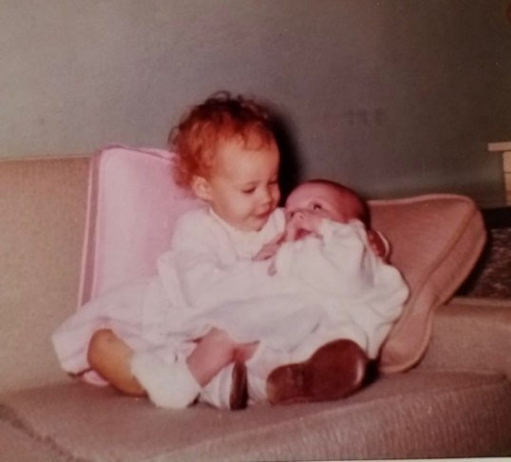

I believe this is the cute picture Dad is talking about.

It was taken October 26, 1959, the day of Lisa’s baptism.

Lisa received a bath robe from Aunt Margaret, today. It is raining this evening and is supposed to turn to snow by morning. We had snow last week as you did (about an inch) but it also melted quickly. I walked to work Thurs noon after driving home at noon. It was a wet snow that morning but was supposed to freeze by evening so I thought I just as well bring the car home. However it stayed warm enough that most of it had melted by the time I walked home that evening. My main difficulty with driving when it snows is the parking lot up by the building. It has just enough slope, and not enough traffic on it, for one to easily get stuck. The main streets are usually clear long before the lot.

“Our” old house is still empty, I guess. I mailed in our income tax last night and we should get $139 back (Paid $101). If we had one more exemption (ha!) we wouldn’t have had any tax as our total income was $3219. The dryer sure uses the electricity – around $4 a month. For two months our light and water bill was $16.55 where it used to be $8-10. Our gas bill for last month, with all the real cold weather, was $16.70. Ruth worked hard this week on the walls in the girls rooms and removed the mildew again.

Lesle talked to me over the phone at noon, today, the best she ever has. She uses sentences (I’m sleepy) (he scribbled out some letters in the word *sentences*) most of the time now. Lisa doesn’t use the basket at all for her naps and of course, has been in the bedroom since Christmas. She needs a lot more room than the basket has so I guess it’s free again for the next “customer.”

We’re all fairly well now but I felt lousy last evening during class and thought I might be down today. I felt better this morning, however. Jerry Smith has been out with the flu, the sec was out a week, the Walaszeks children have been sick etc. Lesle has been hoarse a day or two but has been very active the last two days. Lisa still has a little cough, but its better.

This Sat night we’re going to our s.s. teachers new house for a house-warming party. We’ll work on those braille books. Ruth finished that big one she had, recently (I guess I told you that before). Tonight I fixed the cord on my electric razor and it works better again. It had burned thru and I didn’t want to spend anything on it now. I got it while at KU from the A&A. Last night was the course – 4 more Mon nights and all courses will be finished.

Sun morning I was going to s.s. but woke up slightly light-headed due to some middle-ear congestion so I didn’t go. Ruth started to get ready for church but was somewhat upset (with Dad? or was it just her intestines?) so neither one of us made it again. Grandmother underlined the following sentence. This has been the longest stretch in my life that I’ve missed s.s. and church. When I’m writing my thesis I may have to forego “everything” in order to make it in time. I’m working as much as I can now to get all references accumulated and will try to have a pretty good rough draft by the time we go to Chicago the middle of April.

Sun afternoon we read and I took a little nap (like old times) and in the evening Ruth went to the yearly missionary meeting at the church. The yearly series is held during Feb and we’ve gone the last two years. Sun evening Lesle scrubbed and scrubbed the end table before going to bed. She loves to clean things and thinks she is the only one who can properly “take care” of Lisa. We think she gets along fine with her new sister and although the’re trying at times, I guess the’re generally pretty good children. Last Sat I worked at the building and then rested while the girls were asleep and Ruth went to the library – (Lesle was ‘coldish” then). We were home the rest of Sat. Ruth went to the Brownfields last Fri night and we were home Wed and Thurs nights. Tell Aunt Clara, MJ Bill Jimmy and Uncle Clyde hello.

**2-16-60 – Tues 4:05 PM -** I’ll start this while I’m running an experiment as I have a lot of reading to get done tonight, and Ruth can mail it as she goes to circle. It’s meeting at the preachers house and she is to pick up a couple of women on the way.

Today is very nice and somewhat warmer. We had a bit of snow early Mon morning but it is gone now. I hope we’ve had most of our winter, but in Kansas you never can tell. Last night was our class and we stayed up till after 12 reading. I got home a little early and tried to watch Lesle and Lisa and they both cried and cried ha! Ruth said she had a terrible time getting Lesle to bed. We should be home tomorrow night and Ruth will probably go to choir practice Thurs night.

Sun we were all pretty free of colds so we finally all made it so s.s and church. We had a big crowd at s.s. and the girls got along fine in their room. Ruth came home during church to get ready for the Burfords who were coming for dinner. She, of course, came back for us after church and I sang in the choir for the first time in some time. Ruth went to choir practice last Thurs and Mr. Blim said it was OK for me to sing on Sun morning even though I hadn’t been to rehersal. After church I took Ruth and Lisa home and then Lesle and I delivered two boxes of Valentine cookies to some shut-ins. We packed the boxes of cookies at the house-warming party for our s.s. class teacher last Sat evening.

The Burfords came about 1 and left a little after 3 – Dot (Mrs.) is the one who had infectious hepatitis (liver) around Christmas when they were taking their Christmas vacation in the south. Their boy Mark (10 months) was kinda fussy and wouldn’t take a nap (we moved the crib in the kitchen and we all ate in the living room (moved the table in) as we needed more room any way. I’ve sent in the U.S. income tax (as I’ve mentioned before) but haven’t sent in the state yet. It looks like I’ll only have to pay about $2 to the state. My salary now comes from a government training grant and they do not deduct for social security so that makes a little more. It may also be non-taxable.

Mr. Murray called Sat afternoon from Hutch and I more or less promised him a couple of weeks starting the 12th of June. John Gilmore, the fellow who took Jack Tanners place, can get away at that time. I’ve never heard from Addleman. For now, at least, you might figure on being in Hutch that part of June. Last Sun afternoon we read and rested after the Burfords left and in the evening we all went back to church for the family night program on Africa. We took a sandwich for Lesle, as we were late (Ruth and Lesle had taken valentines up to the Brownfields) and we thought the sandwiches there might be all gone. There were sandwiches left but Lesle wouldn’t eat any and only had cocoa for supper. The girls were both worn out. Sat I was here (lab) in the morning and in the afternoon Ruth and Lesle made their regular trip to the library. In the evening we had a baby sitter and went out to that party. Good crowd there and I led some singing. Got home at 11:15 – The usual closing is missing from this letter.

**2-21-60 – 10:25 PM –** I’ll start this tonight and, as usual, wait to mail it until after we hear from you. I failed to get a final note on last week’s letter saying how sorry we were to hear about Uncle John and I hope that he gets along just fine. I also failed to mention that we were glad to have your last letter. As usual, this coming week will be quite busy. Tomorrow night will be our last regularly scheduled course lectures and then a wk from tomorrow night is my lecture, on which I’ve just barely started. Wed we have a discussion group for which I need to do some reading. Thurs morning Ruth has a check-up with Dr. Spanos and tomorrow morning I’m coming home for awhile so Ruth can take some material to a Singer Store to be made into a belt for a shirt-waist dress that matches one of my shirts.

Your letter didn’t get off last Tues night as we were so rushed with Ruth getting ready for circle. We were home last Wed night and Thurs night Ruth went to choir and on Fri night she went to the Brownfields. Fri I started getting hoarse and yesterday morning could hardly talk. I’m a little better today but still don’t feel quite up to par. I hope we can keep from having a complete round of colds again. Mine is up in my head some tonight.

I went to the building and stayed till about 2:00. It was starting to snow so I came home. We had a baby-sitter yesterday morning and Ruth and Lesle went to the library and did some shopping. After I came home Ruth went for groceries and then we were all home after the snow started accumulating. This morning I put the chains on the car (it snowed 8 inches but is not that deep as it was wet and it packed and some melted) and Ruth and Lesle went to s.s. and church. Ruth had to take care of the nursery (only one this morning) during church. It was so cold for Lisa and I couldn’t have sung a bit. I studied and read all day and we missed church this evening as it’s almost too much for the girls and I needed to work etc.

I guess the work with Murray in June is out as a letter from him yesterday said that he had formerly promised Bellwood, but hadn’t heard from him or something, and then called me and finally heard from Bellwood. He said he might use me a wk or two later in the summer. If I don’t hear from Addleman soon I’ll write him again and then Gene Stucky and others in Hutch about some work. We never wrote the Stuckys after their accident but I assume they got along OK. Sometime I’m going to discuss the possibility with Ed of staying here another year (on a fellowship or grant) to complete some research that I won’t have time for in my thesis and that I probably wouldn’t be able to do for several years and yet I’m rather anxious that they be tried. He may not think it best to stay in the same place any longer. Another letter missing the usual ending.

**No Date – Mon 10:35 PM –** I got home about 10:00 PM this evening. I gave my seminar (45 mins) at 6:30 and then at 8:00 we all went to the library for a lecture by a visiting professor. The other 3 students will give their seminars next Mon night and that will complete our graduate course except for the exam which will be about 3 wks from today. We’ll probably meet for some evening study sessions in preparation for the exam.

We were glad to have your letter today and we enjoyed reading Aunt Clara’s letter which you sent last time. The Laidigs will be here the weekend of April 2nd as Mr. L has a meeting in Topeka at that time. The meeting in Chicago is the 2nd week in April – the one just before Easter. We’ll probably have to miss the Easter week music but will probably try to be back for Easter Sunday. As you say, we’re certainly tired of the winter weather also. I’ve had the chains on the car since a week ago Sunday. The streets are all clear but I need them to get in and out of the parking lot. The snow melts off the roof of our house quicker than any other house in the block. Big icicles form all around the house and the ice completely covers our front steps which makes it hard for Ruth when she goes to the basement.

Lesle was all excited today when she received a package from her grammy. It contained some white dress gloves, ear rings and waterproof panties. She is getting a wagon from her grammy and grandpa for her birthday. The Brownfields have given us their old play pen for Lisa. Lisa turns over both ways quite readily now and therefore won’t stay on her quilt in the living room. Lesle was certain this morning that grammy, grandpa and grandmother had given her all her books. Actually, all but about two were purchased by us but she didn’t seem to think so.

Tomorrow night Ruth has her evangelism council meeting at the church and we’ll probably both be home Wed and Thurs nights since there is no choir practice on Thurs evening. Yesterday morning we all went to church as we were all relatively free of colds etc. Ruth got my hoarseness and we’re both just now getting over coughs. The girls had some cough but not as much as their parents. We both sang in the choir yesterday for the first time (both of us) in about 2 months. After coming home from church Lesle and I played in the snow awhile. She has had little opportunity to play in the snow this winter as she’s usually had a cold when it snowed, etc. We were home Sun afternoon and then all went to the last family night at the church. It was a play about marriage customs in Africa, etc. We all decided to go since the girls had long naps in the afternoon. I wrote my talk in the afternoon and evening.

Sat morning I worked at the building. It snowed all day Sat and into the night but not heavy. In the afternoon I went to the drug store for some cough syrup. Ruth went for groceries and did some shopping. Ruth and Lesle went to the library later in the afternoon. I listened to basketball games in the afternoon and evening and did some reading. Fri night Ruth went to Brownfields and Thurs night picked up a belt she had made as she was too hoarse to sing. Ruth went to Brownfields on Tues as usual. They’ll be leaving in May or June for Turkey so Ruth will really miss her. I guess we’ll have to buy a TV ha! Tell all hello.

On a separate sheet of paper Mom adds: I’m working on the girls’ baby books and have gotten to the family tree part. We need some help on it. Would you send us your entire birthdate (we’re not sure of year) and your birthplace, your parents’ names, birthdates and birthplaces and the same information for Carroll’s father’s side? Our book only goes back as far as great grandparents. And back to Dad on another sheet of paper. Wed morning – Had a letter from Addleman saying he might use me a wk the first part of Aug. I’ll write Murray etc, so it looks like the vacation might be in Aug rather than June. Come up some week-end after the weather is better, if you like. I might have to work some but you could see the girls. We’ve all got coughs today but my hoarseness is better. Mom adds: Thanks for the information for the books.

**3-8-60 – Sunday 11:00 PM -** Ruth went to the Brownfield’s this evening and should be home any time now. Mrs. B was to come by here, today, for Lesle’s birthday but couldn’t make it. The last few days have been very cold and we’ve had snow so many times the last two weeks I’ve lost count. It snowed some yesterday and we’ve had fluries off and on today. I wouldn’t mind the cold and snow so much if we could all stay free of colds. I’ve got one again and the girls have touches also. Ruth is quite tired but hasn’t had quite as many colds this winter as the rest of us. We were both tired today as Lesle was up 4-5 times last night. It was partly her cold, I guess, plus the cold room. We’ve been running our little electric heater in the bedroom until we go to bed and it takes off some of the chill.

Lesle certainly had a big day today. Your package was here yesterday afternoon when we got back from downtown but we didn’t bring it in till after she was asleep. After she saw the dress she immediately wanted to wear it, so she got to wear it to s.s. and church. We hadn’t planned on her going to church at first but her nose wasn’t “running” so we let her go and “show-off” the dress for which she had several compliments. She wore it the rest of the day and Ruth says all it needs is a little taking up in front. Besides the books you sent she received “The Little Engine That Could” and “The Story of Peter Rabbit” from Mother and Daddy. We also gave her one of those jigsaw like puzzles with big pieces – it is a bus. The wagon from Grammy and Grandpa came (disassembled) this last week and Ruth hid it under the couch. Lesle knew when the box came and could see it but I guess she didn’t demand to see inside. It is a nice big red wagon with rubber tires. I assembled it last night after the girls had gone to bed.

I stayed home this morning while Ruth and Lesle went to church. The choir was small but I couldn’t have sung very well anyway. It was so cold this morning that the washer wouldn’t start without first heating some with the electric heater. Ruth and Lesle picked up some film and flashbulbs on the way home and we took pictures of the girls including Lesle’s expression when she first saw her birthday cake. After relighting the candles about 5 times (after I blew them out) she finally blew them out all by herself. Lesle was tired and finally took a long nap from 2-5:30. Ruth just came home and brought a present from the Brownfields for Lesle – some terry cloth panties. Ruth was finishing the aprons at the Brownfields for some plaid matching dresses for the girls with white collars and pleated from a yoke. (I don’t know what it means for sure.)

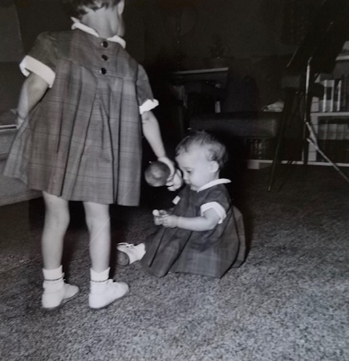

The matching plaid dresses.

Lisa finally took a good nap this morning and one this afternoon (after interruptions) after having only about 45 mins yesterday. She actually doesn’t sleep much more than Lesle and both girls have been getting up between 6:30 and 7:00 each morning (closer to 6:30) which is a little earlier than we want to get up although we get things done and I get to work a little earlier, but we’re so tired at night.

Tomorrow night is the last night of the graduate course with the other 3 student seminars. I have a lot of literature work to finish this week and then will have to spend a week studying for the last written exam that I’ll have to take. The final exam, which is mainly over your thesis, is entirely oral. So many interesting aspects have turned up that I’m really going to have to work hard to finish up the experiments adequately in the next two months. I may have to call on Ruth to help with some of the records etc.

I guess we’ll be home most of the other evenings this week. Yesterday morning we all went downtown for some shopping. I bought Lesle a little bunny rabbit. It was snowing as we were coming home and beginning to get slick. We stopped for hamburgers on the way home. In the afternoon Ruth went to the library by herself because of Lesle’s cold. Ruth also got Lesle a little black rocking chair for her birthday as well as an “Old Woman in the Shoe” bank. She stopped at the grocery on the way home.

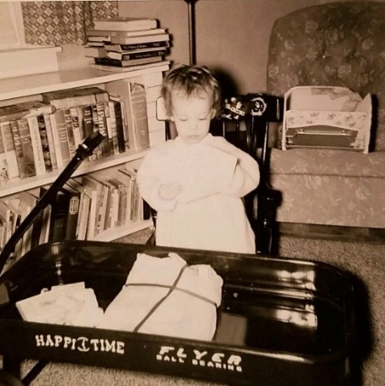 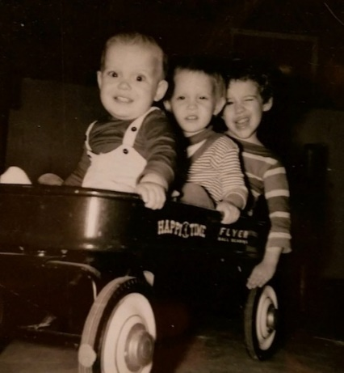

Lesle with her birthday wagon and rocker.

All three in the wagon in 1962. We used to use it when we walked to the library in Decatur.

Last week Ruth had her evangelism meeting on Tues night and went to Brownfields on Fri. We were home the rest of the time. We were glad to have your letter and Lesle your card as well as the gift. Tell Aunt Clara, Uncle Clyde, M.J. Bill and Jimmy hello.

**3-21-60 – Mon evening 9:35 -** I’m sorry I didn’t write last week but I knew you were in Texas for part of the time and I had to study for my exam today. The last two or three days have been considerably warmer with quite a lot of the snow melting. However, tomorrow is supposed to be colder again. The temperatures here have been averaging about 20-30 degrees below normal and Ruth is anxious for warmer weather so she can get the children outside. I’ll be glad when it’s warm enough so I can wash the car. I finally burned the trash tonight which had been accumulating for about 10 days. Our back door has gotten so tight this winter that we keep it locked all the time and use the front door exclusively. This makes it rather inconvenient when we want to go in the back yard.

You will have read, by the time you receive this, of the appointment of Dean Wescoe as the new chancellor of KU. He was and is considered a pharmacologist and came here as a member of the Department of Pharmacology. It is a possibility that Dr. Peters will be offered the deanship here although he might turn it down. Ed doesn’t think it’ll be offered to him.

We were glad to have your cards and letters during and about your trip and were glad you made it OK. I thought you might be delayed a day or two by the snow as snowed considerable here a week ago. I still have the chains on as haven’t had time to take them off.

Last Sat we got Lisa a new jumper chair. We had an old one but it would tip over occasionally. This one is similar to the one we had borrowed from the Holadays for Lesle. Eldon Laidig will receive his masters in education from the University of Texas and since he will need some more teaching experience before he can get a Phd he plans to take a job for next year. He is considering two positions, one in Texas and the other in Colorado. Mr. and Mrs. L plan to be here this weekend. Lesle is, of course, looking forward to seeing Grammy and Grandpa Picklepuss. She would also be glad to see Grandmother, Aunt Clara, Aunt Jan, Uncle Bill, Uncle Clyde or any other relatives who would like to come see her. She was excited today when a package came for her from Grandpa Puss containing a little practice golf ball (hollow and with holes).

Ruth went to the Brownfields this evening and is working hard to finish the baby quilt which she is making from small squares of material from all the materials she has used in sewing. She has finished the aprons (with little duck pockets) for the girls and they look real cute in them.

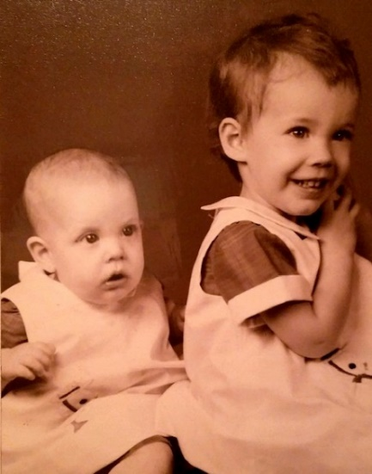

Lisa and Lesle in their matching aprons with duck pockets.

Tomorrow night is choir practice rather than Thurs and we’re hiring a baby-sitter so Ruth can go to the practice and I’ll go to the library and get started on my final library search. The abstracts for the Chicago meeting are out and I’ll send you a copy as soon as the reprints arrive. There will be 5 papers from our department with Ed’s name on 3 of them. Hugh Burford is giving one also. Although the abstract has been written I still have to write the full talk although it only runs 10 mins with 5 mins for discussion and questions. Ed helped me fix the records so the slides can be made from them.

Our exam went OK today and Hugh, Jerry and I finished setting up the student lab for tomorrow this afternoon. These are the labs for the sophomore medical students and I’ve been assigned 16 students to sorta take care of and then grade in the end. At the present time I prefer research to teaching. Positions in medical schools, of course, require both. I think I would prefer the teaching of graduate students rather than medical students.

Yesterday morning Lesle refused to eat her sausage so she had to go without breakfast. We all went to s.s. and Ruth was going to bring her home during church since we felt she would probably be so fussy. She got home and found she didn’t have her house (key) so she and Lesle went back and went in the balcony awhile. Lesle finally saw me in the choir and called out Daddy loud enough that I could hear it. Ruth had to take her out as she was talking too much. We picked up hamburgers on the way home from church so Lesle could eat right away and go to bed for her nap. We’d like to eat out on Sunday but it’s so difficult when Lesle is tired, hungry and fussy.

Ruth just got home and said that someone had moved into the Denny house today. We’ve about decided that the only real advantages of this house are the location, the slightly cheaper rent and the fenced in backyard. Last Sat we went downtown in the morning and stopped by the library on the way home. We studied (the 4 graduate students) at Hugh’s in the afternoon and at Jerry Smiths in the evening.

Today during the exam I actually saw Jim Fevurly (the graduate student from microbiology minoring in pharm. – about 31-32 yrs old) use notes he had written up. On two other occasions I had suspected he was cheating but I was not completely sure until today. We’re not saying anything about it now but I may say at a later time that we suspected him. He’ll be shown up when he takes his orals etc. He flunked the basic course two years ago and he was only allowed to go ahead with pharmacology as a minor if he showed marked improvement when taking that course over last yr and when taking the graduate courses this year.

Last week I had a seminar Tues night, Ruth went to the Brownfields Wed night and to choir Thurs night. We all went to s.s. and church a week ago Sun. Our schedule for a week ago was about the same as usual. Tell Aunt Clara, Uncle Clyde, MJ Bill Jimmy and Uncle Clyde hello. When are Uncle Clyde’s and Bill’s birthdays. We have been asking Lesle what her name is this week and she usually says “Danny” (Musgrave) or “Uncle Bill” first.

**3-28-60 – Mon 11:30 PM –** We were glad to have your letter today and the enclosures. We received a note from Mrs. Bill Lester today inviting us out while we are in Chicago. I thought I had mentioned it but the girls are not going with us. Lesle will stay at the Brownfields and we’re not sure about Lisa as yet. The Burford boy (1 yr.) has been having a lot of trouble with respiratory infections and they have thought that he was getting it from another baby at the place where he has been staying during the day. Anyway, Ruth started keeping him today so he would have a change of places. I guess they’ll pay us the regular price. Mrs. Burford is not going to Chicago (she is a nurse) and she might take Lisa at night when we’re gone and then leave her boy and Lisa with someone during the day. Ruth got along OK with the 3 but was pretty tired tonight and the extra lifting was hard on her back.

The snow is all gone now and it has been spring like since Sat. Ruth and the children took a walk today. Mark (Burford) and Lisa rode in the piggy-back stroller and Lesle walked. Lesle spent most of the rest of the time in the back yard. She got outside in the yard to play for the first time on Sat. Although she didn’t eat much lunch she had a big supper and has put on some wt since we’ve started giving her more vitamins, protein, ice-cream etc. With the back door open some we’ve been troubled with a lot of big water bugs. Ruth hates them so I have to get them every so often. There were 9 in the kitchen sink this morning.

I gave Lesle a bath tonight so Ruth could get away for an errand downtown. She got 2 copies of “Open the Gates of the Temple” which I’m singing Wed night at the “99” class showing of an Easter film and dinner. They really didn’t ask me till Sun and as usual I hate to turn people down. I’ll have to learn it in the morning and tomorrow night. Ruth also went to the library tonight and then borrowed another highchair from the Brownfields. Thurs night is choir and I may go to library if we get a babysitter.

I made an A in our last graduate course. I was quite satisfied considering the time I allowed for it. We all (Hugh and I, the other 2 didn’t take them last yr) did better last yr but I had more time for studying. I’m now finishing up the major part of the library and reference work for my thesis although I won’t have a rough copy by the time we leave for Chicago. With the references in good shape I should be able to make it after that. The meetings are the 2nd week in April. We may take parts of 2 days to drive. The meetings start Mon morning but Mrs. B doesn’t want Lesle till Sun so we may not leave till Sun and then get there sometime Mon. My paper is on Thurs and Edds is on the same section. Hugh has one and there will be 5 from our department all together. Hugh has been under some criticism because of apparent lack of ability to write up a good research paper on some work he did with Ed last summer. He is doing better I guess. I’ll have to get in practice writing, again, and I’ll have to write the abstract work up for a complete larger paper and probably one or two papers to be written this summer.

Haven’t heard from Murray or Addleman as yet about summer. The Laidigs arrived about 10:30 Sat morning while I was at the library. Lesle had been looking forward to seeing Grammy and Grandpa and, of course, was quite excited. Grandpa, Lesle and Ruth went to the grocery store and we all ate when they got back. While the girls had naps Mr. L and I rested some and Mrs. L and Ruth went out to GEM. Mr. L went out to visit Mr. Mahon later in the afternoon. Mr. Mahon is the former High school principal and superintendent at Oberlin who is now here.

We were all home Sat evening. Mr. L slept as he was pretty tired and Ruth and her mother looked at catalogs and played Anagrams. Mr. L bought Lesle a new wooden jig-saw type puzzle of a tugboat which she has already learned to put together. Sun morning they left for Oberlin as we all started to s.s. and church. We sang in the choir and got hamburgers on the way home. We were home the rest of the day except when Ruth and Lesle took a walk.

I can’t remember for sure what else we did last week except that Ruth went to the Brownfields Fri night. The minister at the Oberlin Pres church is planning to leave – he hasn’t been there even two years. The fellow who I’m sure was cheating made much better grades on both of this years exams than any of the staff thought he would. They also give him 10 points handicap which made his grade 77, Jerry had 79, Hugh 81, and I had 86. They’ll show him up on his orals if he really doesn’t know it. Commencement is the first Mon in June. It might be easier if you could come here some week-end. If you want to come for Easter Sun we plan to be back sometime the Sat before. We could hide the key or you could wait at the Brownfields until we got in. Tell Aunt Clara, Uncle Clyde, M.J. Bill and Jimmy hello.

**4-?-60 – 5:00 PM Tues –** I’ll start this while I’m still at the building and running an experiment. The last few days have been a little cooler than it was for awhile but it is gradually getting warmer again. Lesle sleeps longer and eats more when she can play outside. I can’t blame her for wanting to play outside after having been in all winter.

I thought we’d receive your letter today but since we didn’t I will go ahead and mail this in the morning. Jonathan Mark Burford (graduate student’s son) started staying at our house during the day a week ago yesterday. All 3 children had runny noses last week but some better now. Ruth is getting used to the extra work and takes them all 3 walking in the “piggy-back” stroller. Lisa and Mark (he’s just 1 yr old and beginning to walk) ride in the stroller. Yesterday morning they all went over on Rainbow to take the choir robe collars to be cleaned.

Ruth was asked to (Now Wed morning) play the drums for the new medical center orchestra. They will have a concert sometime in May. Last night Ruth had her evangelism committe meeting at the church. I went to the library and we had a baby sitter. Tonight we’ll be at home and then tomorrow night Ruth will go to choir practice and I’ll go to the library. Fri night Ruth will go to the Brownfields and I may go to the library.

We’ve about decided we’ll go to Chicago on the train rather than drive. The only reason for driving was to be able to easily visit some of the areas where we might find a place to live. Since we won’t actually have much extra time, anyway, and since it’s so crowded in downtown Chicago it will be easier not to drive. We’ll probably not leave here until Sun night as I’d written for Mon night as the first night for the hotel. We’ll probably leave Fri evening to come home. Ruth says she needs a rest from the children but is already homesick for them. Dallas Musgrave (went to KU 2 yrs) has quit the college in Chicago where he was going (his girl friend was there) and is now working at some bank there. We’ll try to see him. Ruth wrote the Lesters a note saying we were anxious to meet them.

I guess Mrs. L lost out again on the Kansas “Mother of the Year.” It’s kinda political and depends a lot on the amount of backing you have, the club behind you, etc. She had not planned to reenter this year but did after receiving a letter from one of the ladies in charge saying that she had lost last year by a 6-5 vote and should reenter. We haven’t heard yet how Mr. L came out on his running for the district governorship of Rotary in Northwest Kansas. The meeting was Sun-Tues in Salina. The L’s are going to visit Eldon over the Easter holidays. Eldon has signed a contract for next year to teach in Jefferson county Colorado. It is somewhere near Denver. As I told you he plans to get a Phd some day but in education you have to have at least 5 yrs of practical teaching experience – he has only one since he was in the service.

I studied at home Mon night and Ruth went downtown to leave material for a belt to be made for a new black outfit she is making. It is from that black material I bought for her at Christmas in Hutch. She is now wearing the new dress her father got her for Christmas and which she hadn’t altered earlier. She has quite a lot of shopping she wants to do in Chicago.

Sun we all went to s.s. and church – Lisa has been about the only baby for a few Sundays but I guess there were 2 or 3 this Sun. We thought about La Verna’s wedding last Sun. We got our hamburgers on the way home and it was a good thing as Lesle was a terror. She is so sweet one day and a terror the next but I guess that’s typical of 2 year olds. She gets so exhausted on Sunday that she’s almost too tired to eat. If it keeps up we may have to keep her home from either s.s. or church. Perhaps it is simply too much stimulation for the little introvert ☺ We both sang in the choir Sun.

If you plan to visit Aunt Margaret next summer, maybe we could take you or bring you home and see some of the housing then. We probably couldn’t spend but a day or two. I haven’t heard yet from Murray or Addleman. We were home the rest of the day Sun except that Ruth and Lesle went to a drug store awhile. Sat morning I worked at the library. In the afternoon Ruth and Lesle went to the library and grocery store. Last Fri night Ruth went to the Brownfields and Thurs night Ruth stayed home and I went to the library. Guess that’s about all the news hope everyones fine there. Tell Aunt Clara, Uncle Clyde, M.J. Bill and Jimmy hello.

**4-16-60 – Sun 8:30 PM –** We’re leaving on the train about 11:00 PM and will get into Chicago about 7:30 in the morning. We had originally made the hotel reservation starting for tonight but then we decided to not go so soon. Today has been a little warmer but the last few days have been rather chilly and windy. We’ll be so glad when it really gets warm. It has even been too chilly for Lesle to play outside some of the time.

It has sure been quiet this evening with both children over at Mrs. Hartman’s. As I wrote you Mrs. Brownfield was to have taken care of Lesle – but then Jule (little boy) came down with the mumps so that changed our plans. Mrs. H has a 19 month old of her own and then keeps 3 other babies during the day. She had promised to keep Lisa and said she was “game” about Lesle if we were. She’s charging us $10 a day for both which isn’t too bad when you consider that she gets $2.75 for 8 hours during the day.

Their address 2114 W 39th Tel YE2-2081. Ruth is dropping by their place in a little bit to see how they got along and then will take the key up to Mrs. Brownfield – 1801 S. Mill St. Terrace FA1-3142. She come by a time or two to check on things. We took the girls over to the Hartmans about 5:00. Lesle played in their backyard sand pile and seemed to like it OK. I think she’ll get along just as well there as at the Brownfields as the 19 month old boy is about her size and they played well together. Lisa will be there too which will help. Mr. Roger Hartman is a junior medical student and they’re right across the street from the nurse’s home at 39th and Rainbow. She is the one who kept Lesle when Ruth was teaching some.

Wed night is the pharmacology banquet and we may try to go to a show one evening also. We had a nice note from Mrs. Bill Lester saying for us to come out on Fri and stay for dinner. We’ll try to do it unless something comes up that I can’t miss. We’ll leave Fri night. We all went to s.s. and church this morning. Our s.s. teacher had a hernia operation but is getting along OK, I guess. We sang in the choir and therefore got to help with the special music. We’ll miss the Thurs night meeting with music (Maundy? Thurs). We were home until we took the kids up to the Hartmans.

We were glad to have your letter. Another reason we didn’t drive was that the car needed a going over and I just hadn’t gotten to it. Yesterday morning I worked at the library and then Ruth went to the store while the girls were asleep. Ruth and Lesle went downtown and to the library later in the afternoon. We were home in the evening. Last week we had a babysitter on Tues, Thurs, and Fri evenings as I went to the library and Ruth had that church meeting, went to choir and to the Brownfields. I guess we haven’t done much else since I wrote last. Tell Aunt Clara, M.J. Bill, Jimmy and Uncle Clyde hello.

**4-23-60 – 8:00 AM –** I meant to write last night but didn’t get around to it. We had a fine trip to Chicago but Ruth and I have a touch of sore throat this morning. I hope it doesn’t get any worse as Ruth couldn’t keep Mark if it did. While we were gone last week Mark stayed with one of the couples that they sometimes trade off baby sitting with. I was just interrupted as Lisa vomited up her entire breakfast. She’s had a touch of diarrhea, but no fever so we’ll watch it. Lesle was a terror yesterday so Ruth will be ready to go back to Chicago if they don’t improve.

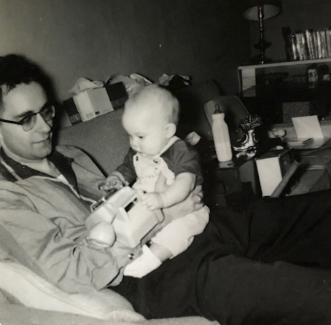

Dad holding 7 month old Lisa. Lisa is not vomiting.

Today and yesterday have been warmer after some rather cool ones. Ruth and the girls walked up to the building and rode home with me. That makes it nice when I have a late experiment as I don’t feel quite as rushed. Yesterday evening I was home while Ruth went downtown and by the Brownfields. They’ll be leaving in 3 wks for Turkey so we’ll have to return the 3rd high chair which we use for Mark. Lisa chair came while we were gone and is the fold down type.

Tonight Ruth has her circle and tomorrow night will go to that Med Center orchestra practice. Thurs night is choir practice. We may get a sitter for 2 of the 3 nights so I can go to the library. Dr. Walaszek was not back from Chicago yesterday but should get in today. Their families (folks) are in Chicago so they usually stay longer. Dr. Peters made it to my paper and said it went fine, as Ed said also. Mine was in a long, not too large, narrow banquet room. It was about ¾ full and had been crowded for some of the earlier sessions.

Lisa now crawls fairly well which is something Lesle never did. Mrs. Hartman wrote us in Chicago that Lesle awakened the first night wanting Mama so they let her sleep with them. Lesle vomited Tues morning which Mrs. H thought was probably lonesomeness. It rained the last part of the week so she didn’t get to play in the sand pile too much. They all went to a drive-in movie on Fri night. She charged us $55 for everything. Ruth has already made half that back by keeping Mark.

We got Lesle some new books (4) and a triangle in Chicago. Ruth wrote Lesle a card almost every day. Ruth bought some new materials. Lesle got a pair of shorts with a crop top and a diaper set with a bonnet for Lisa. We brought Mark a cuddly rabbit. Lesle had a big time with the Easter baskets and eggs you sent. Mrs. L sent some little plastic bunnies, chickens and ducks for Lisa, a big chicken for Lesle and each a pair of waterproof panties.

A wk ago Sun night we took the 11:00 PM train and got into Chicago about 7:30. We slept some but were tired on Mon. We took the sewing machine (!) and Ruth finished her black outfit for the banquet Wed night. She also worked some on her quilt for the Corman’s baby. We may go visit them in Lawrence next Sat. Ruth enjoyed the shopping at Marshall Fields, Goldblatts, Carson Pirie Scott Co, etc.

I attended 7 of the 10 sessions – one each morning and afternoon. On any given morning or afternoon there were 3-4 sessions going on at the same time in pharmacology plus some sessions of general interest and the sessions in physiology, biochemistry, microbiology, pathology and nutrition. This was the largest meeting of all time with 8-10,000 registrations and 2600 papers.

We walked around some Mon evening and Ruth sewed Tues evening. Wed was the banquet and Thurs evening we took Dallas Musgrave out to dinner and then had a long talk with him in the lobby. He is working at the First National Bank in downtown Chicago but wants to finish his degree sometime. He was attending a small church school in Chicago where his girlfriend was going but dropped out at the end of the first semester. The banquet ($5) was nice and Prof J.H. Gaddum of England gave the talk on the history of pharmacology at Edinburgh. That is where Ed spent a year and is one of the cradles of pharmacology in Europe.

We called the Lesters on Wed evening and made plans for Fri. Thurs morning we took a walk over on Michigan Avenue and saw the new tall Prudential Building. We didn’t walk clear over to the outer drive so we could see the lake but walked by the Art Institute. Fri morning Al Poisner and I took the subway and elevated out to the medical center of the University of Illinois and the Cook County Hospital. Al is interning there and plans on doing a research problem with the fellow I might work with. I got to meet him. He is in charge of the basic research at the Neuropsychiatric Institute which does not (most of it) deal directly with patients. He said they live in Oak Park (about 15-20 mins drive – not as far as the Lesters) but did not know how the rentals might be.

Fri afternoon we took the train to Hinsdale (about 30 mins). Bill and Maurine met us and it is about 10 minutes to their lovely home near the hospital. We had a most enjoyable time. Bill is carrying on some research and gave me a pile of his publications since 1948. He is chief of the medical staff but has some time for research. When you figure his home he probably makes more than Dr. Peters. He is also associate clinical professor of medicine at University of Chicago (Ed’s school) and goes in on Sat morning. Bill showed me the hospital and later (before dinner) took us a ride. Bill is somewhat on the heavy side and possibly looks some like his father as I remember him. I told him I thought you had a Kodak of him in Daddy’s helmet and with the rifle? Steven had the measles so stayed in his room (7 yrs) and Ricky is 12. We were very glad we went and I wasn’t aware I had such an important cousin. I guess he was one of the top men in internal medicine while he was at Chicago full time.

We took the train back Fri 10:00 and got here at 7:30. We got the kids, Ruth and Lesle went to grocery store, I went to building a bit, Ruth and Lesle went to library etc. Sun we all went to s.s. and church. We didn’t make in time to sing for the 8:00 service. Lesle wasn’t sure she wanted mama to leave her at first but was all right later. We got hamburgers on the way home. Ruth went to the Brownfields in the evening. Had your letter. Tell Aunt Clara, Uncle Clyde, MJ Bill and Jimmy hello.

**5-2-60 – Mon 10:00 PM –** It is cooler this evening after several warm days. It rained last night and early this morning. We were glad to have your letter today and to hear the news. I just came back from the library after having come home from the building about 7. Tomorrow night Ruth will probably go to the Brownfields but will miss her orchestra rehersal Wed evening. She went last Wed night as the other drummer was there. They still haven’t obtained any drums so it doesn’t do much good to go. Ruth bought a pair of tympani sticks when she was in Chicago. Thurs night we’ll hire a baby sitter – Ruth will go to choir and I’ll go to the library.

I hate to disappoint you but it looks like I won’t formally finish till the end of the summer. The reason for this is that I’ve had too many good research results. When I first started on my thesis work my results were largely negative. Everything “broke” last fall and from then on I had more problems than I could handle. I thought last winter that I could get most things done by this time. However, in the last couple of months some more problems opened up and I was snowed under. By working in the lab till about June 1st I’ll finish most things for my thesis. I’ll start writing then and should be done in time for a good vacation in Aug. Even as it is I’ll have to leave one problem partially undone because of lack of time. It should be good for a publication so I’ll try to finish it at the end of the summer. This is all to my advantage as I may obtain as many as 9 publications from my thesis. With 2 from my masters and one other I may have as many as 12. This is a very high # for while still being a student and should be a big help. As you know its a highly competitive game and advancement depends largely on your research.

I’ll be applying before long for that Public Health Post Doctorial Fellowship. I’ll apply for it starting around Oct 1st and will figure on spending at least one year at the Neuro-psychiatric Institute there in Chicago. I should get the fellowship but, of course, you’re in competition with others. As I think I told you the institute is doing largely basic research (not much directly with patients) and is where Dr. Walaszek was for a year before he came here. They are starting a section in pharmacology at the Midwest Research Institute here in K City. They’re interested in neuropharmacology and if I had that yr in Chicago out of the way I’d be quite interested in it. They’re having trouble getting someone because of the location and salary which isn’t high enough to get someone who is well established. This job might still be available in a yr. I may go talk to them sometime.

Dr. Walaszek has been offered a $15,000 a yr job at a new neurological institute at Princeton, NJ. He is undecided yet whether to take it. He says if he takes it (would start this fall) he’d like for me to go there too, sometime. I, of course, would prefer something closer to Kansas since we’re both “close” to our families. The more I think about it the institute type of job sounds good. They make $2-3,000 more than in a university and have just about as much security. You have more time for your own research ideas than in industry and in academic jobs you sometimes don’t have too much freedom when you’re starting out. I have so many ideas that I’d like to work on that I might be frustrated if I couldn’t carry them out. If we have our 6 kids (?!) I may need a little more money to put them through school. I’m writing tonight for the last of my savings which will last a couple of months. Ed will pay me $500 a month for July, Aug and possibly Sept. I hope to work in the stores in Aug but haven’t heard from them (Murray and Addleman) as yet.

Why don’t we plan a little vacation at commencement time even though I won’t be walking down the hill. As you suggested you could spend a few days here if you’d like. As to Mothers day we might possibly get away. We have invited the Brownfields for a farewell picnic supper on the following Mon. Let us know if M.J. and Bill will be able to be with you or not. You could come here if you’d like.

Lisa got over her upset but Lesle still has some diarrhea. She vomited about last Thurs and has been upset ever since. She had a fever at first but seems to feel fairly good most of the time. We’d had some medicine from the Dr. and will call him again today if she isn’t better. Of course, she hasn’t gotten to play outside or anything. Sun morning I stayed home with Lesle while Ruth and Lisa went to s.s. and church. We were at home the rest of the day except in the evening when Ruth went to the grocery and to the Brownfields. We cleaned up around the house etc.

Sat morning I went to the building and in the afternoon Ruth and Lisa went to the library. After that I washed the car and then took it down for an oil change, etc. We were home in the evening. Fri evening Ruth went to the Brownfields. Thurs evening I went to the library. Wed evening I went to the library and Ruth to orchestra. Tues night Ruth had circle. Mon Ruth went to library and downtown.

Yes, we liked Maurine Lester very much. I guessed Bill’s salary as somewhere in that range. That probably figures as about the same or more than Dr. Peters gets. Must go to work (its Tues morning). Tell all hello. I did my best to make it for this commencement and mainly on your account because I knew you had looked forward to actually seeing me graduate. Well I can make a trip back a year from June and participate if I desire.

**5-3-60 – Tues 11:00 PM –** We’ve been reading awhile after arriving home. Ruth had her evangelism council meeting and I went to the library and then met her over at the Keeler’s (He’s our former s.s. teacher). Joyce Keeler (H.S. girl) is playing for me as I sing “Bless This House” at the Mother-Daughter banquet tomorrow night. Ruth is the toastmistress so can’t very well play for me. Our s.s. class sponsers it each year. I sang “Irish Lullaby” last year. Some man is going to talk on flower arranging for the women. I’ll probably leave after my song.

We had a sitter tonight and will have one tomorrow night also. Thurs night Ruth will go to choir practice. I don’t know what to say about this week-end. Ruth doesn’t feel like she should ask the Burfords to leave Mark at the other baby sitters for Fri since they brought him here to get him away from there. The Brownfields are leaving on Tues so she doesn’t think she can change their coming for Mon night. If M.J. and Bill won’t be there why don’t you come here. That, of course, would leave Aunt Clara but she is welcome to come also. We could possibly go down Sat and come back Sun but it’s pretty tiring. Why don’t you call us one way or the other.

We were home yesterday evening. Ruth has been doing some house-cleaning and just finished the girls’ room. We’re going to have to hire some boy to mow the yard as the grass is almost too tall for Lesle. This evening Ruth and the girls walked up to the med center. I had forgotten to take the double stroller out of the car so they had to use the old single one and Lesle had to walk. We ate at a drive-in and Lesle was so tired that she actually walked in her bedroom and got in bed. We’ve taken off part of the railings so she can get up by herself in the morning. Once in a while she still calls for one of us to get her out of bed. She is putting on some weight and is eating better now that she can play outside. She had her big new wagon out yesterday and today.

I may not have mentioned that Mrs. L had a painful ulcer attack while in Texas at Easter time and has had to go back on her special diet. I guess she’s controlling it again. Ruth called her last night and invited her down to the banquet tomorrow night. She said she’d let us know but we haven’t heard as yet. She had some other things planned.

Sun we all went to s.s. and church. Lesle, as usual, was quite tired and easily upset by noon so we got our hamburgers on the way home. Tonight at the drive-in she ate most of my pecan pie so I didn’t have any dessert. Sun afternoon Ruth and Lesle went to the Brownfields and then back by the grocery. Sat morning I worked at the building and then was home in the afternoon. Ruth and Lesle went to the library.

We’re glad you liked the pictures. We had a very difficult time getting both of them happy at the same instant. Lesle is at the age where things like that upset her. Last Thurs at supper time we went to the Plaza and got Lisa her first pair of shoes. She stands up but may not walk quite as soon as Lesle. We had Lesle’s shoes checked and she cried when the man felt of her foot etc. I guess 2 year olds always have a “rough” time.

Thurs night was when we left the pictures at the hotel for Aunt Clara. Ruth went to choir and I went to the library. Fri and Tues nights Ruth went to the Brownfields and I guess that was about it. Glad to have your letter and tell Aunt Clara, M.J., Bill, Jimmy and Uncle Clyde hello.

**5-12-60 – Thurs 12:30 PM –** I’ll write this while I’m at work as we have student lab today and I’m not running an experiment. I may go home early so Ruth and Lesle can go to the library. We may go to Lawrence Sat to visit the Cormans if the girls are feeling OK. They’ve both had runny noses again and Mark is staying home today because of a cold. Its, of course, impossible to keep them completely separated and we never know who gives whom their colds. Mark is quite susceptible to respiratory infections and they think he may also be allergic.

We were glad to have your call Sun and thats why I’m late in getting this letter off. Thanks also for the Mother’s and Father’s day gift. We may use it for a night out one of these times. The last few days have been rather cool which has made it rather nice for Ruth and the kids. A few times its even been too cool for Lesle to play outside and we usually have the furnace on at night.

The Brownfields left the first part of the week. We purchased their air conditioner for $50. It is several years old but is a large one and has given them surface (service?) It was so unberable last fall when there was no breeze that we decided to get it. With the baby etc. it would probably be very hard. We got some flowers and stones for the flower garden from the Brownfields also. As I told you Capt. Brownfield (with the air force weather division) has been assigned to Turkey for 2 years. He is a career man and has 10-20 yrs still to go.

Tonight is choir and Ruth will go there while I go to the library. A week from tonight is the medical center orchestra concert. Ruth is playing the drums and they had a rehersal last night. They will practice again next Tues evening. Tues night we went up to get some rocks from the Brownfields and stopped awhile at the Luckies’ (neighbors from where we used to live). I hadn’t been up by the old house for several months. The yard doesn’t look any better, if as good, as when we were there. As I may have told you the chimney fell in this past winter and Mr. Denny fixed it himself. Maybe we moved in time?

Last Mon night Mr. Brownfield brought the air conditioner by and put it up for us. Tues morning Lesle and I took the lawn mower to be sharpened, went to the post office, bank and by the Brownfields to pay for the air cond and get some rocks. Last Sun night Ruth went up to the Brownfields for a final visit.

Sun morning we all went to s.s. and church. Lesle was pretty tired from the day before so Ruth stayed with her during church. We got hamburgers on the way home and then cleaned up the house and got ready for the Brownfields. They came about 4 and stayed till about 6:30. We had fried chicken, baked beans, potato salid and chocolate ice cream sundaes. We were eating when you called.

Lesle played pretty hard with the 3 Brownfield children. She gets along pretty well with them but they play somewhat rough and Lesle is so little that she often gets knocked down. Last evening we were playing on the bed and she got a bruise after hitting her head on the head. The other night we were awakened at 2:00 AM when Lesle fell out of bed. As you know she’s been sleeping without all the railings on her bed for some time now.

Last Sat morning I worked here and in the afternoon Ruth and Lesle went to the library. As I told you the banquet went off OK. I left right after my song and went to the library awhile. Ruth was tired Thurs night and did not go to choir practice. A wk ago Tues night Ruth had her evangelism meeting at the church. Afterwards we went to the Keelers and I practiced with Joyce Keeler. The girl who played for me. Let us know when you all will be coming. Tell Aunt Clara, Uncle Clyde, M.J. Bill and Jimmy hello.

**5-22-60 – Sun 7:30 PM -** We’re resting in the living room after having worked around the house most of the day. I’m sorry I didn’t get this written earlier. We all stayed home today as the girls are getting over the chicken pox. They had bumps and runny noses 10 days ago but we thought they were chigger bites at first. I had never seen a case so didn’t recognize what it was right away. They’ve gotten along fine and have been kept in the house. They say the cases are light this year and so it seemed to be with theirs. They both were tired today and went to bed early, however, the’re fussing right now. You don’t do too much for chicken pox except put something on to keep them from scratching and then keep them quiet.

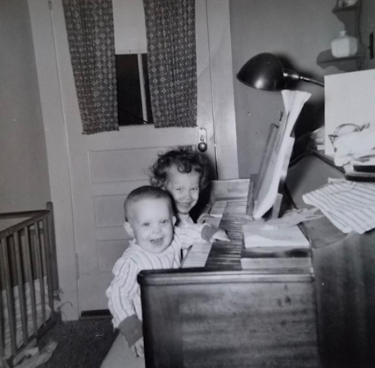 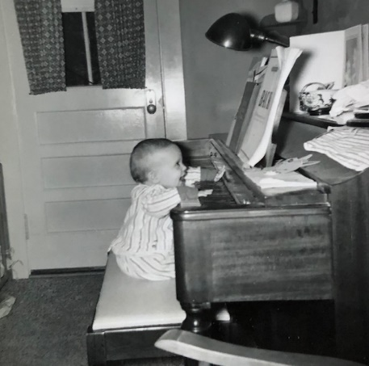

May 1960 – Lesle and Lisa with chickenpox. We don’t appear to be too upset about it.

We’ve had the air conditioner on today for only the second time. The days have been cool for this time of the year and we’ve often had the furnace on in the morning. Why don’t you plan on coming this next weekend even if M.J. and Bill can’t. We, of course, were sorry to hear of M.J. and Bill’s misfortune. The lady across the street has 5 children and she is RH negative while her husband is positive. The last child had to have a transfusion but there was no danger to the mother. Mrs. L is - and Mr. + and they had no trouble with Ruth.

Today is the first day we’ve all missed church since that big storm last winter. We were all tired from a busy week and needed to go easy for a day. When we all get ready on Sun morning it is the most hectic time of the week and we’re always late. I guess we’re just slow folks. We had the lawn mower sharpened and I mowed the back yard this past week. As you remember I had to hire it done the first time. Now I need to clean out the basement and polish and wax the car. This week will be slower than usual. Ruth will go to choir Thurs night and to a show Tues. We’ll hire a baby sitter and I’ll go to the library.

Yesterday morning I went to the building and Ruth went to a going away coffee for Sylvia Mahon the daughter of the former Oberlin superintendent and high school principal. We had a sitter. In the afternoon I babysat Mark (they were going to a picnic) while Ruth went to the library and later to the grocery store. I got a sample of what Ruth has been going thru every day. The Burfords have found a lady to take care of Mark at home so he won’t be here after June 1st. He started April 1st. He, of course, was exposed to the chicken pox but hasn’t come down yet. They decided not to give him a shot (which makes it milder) since the cases are mild this year. They got back from their picnic about 8:00.

Fri night was a department dinner at the Peters. We had never been in their house which isn’t a great deal fancier than many. The Burfords and ourselves are the only ones who don’t drink. We got home about 12:00 PM. Mark stayed here with our baby sitter. Thurs night was Ruth’s concert. I sat with the Burfords – there were about 150 there. It was real good and was held at Bettenfield Auditorium in the Student Union Building. There were a few professionals hired for the orchestra but they were in the minority. The other drummer was a colored fellow who is quite nice. We had a visit with them at an after concert party held at one of the orchestra members house. It was a threatening evening and rained some which probably held the crowd down. I had never heard Ruth play and I think she enjoyed doing it for them.

We were home last Mon and Wed nights and Ruth had rehersal on Tues night so she had to miss her circle meeting. Last Sun we all went to s.s. and then took Lesle into church for awhile. She was quite fussy (coming down with the chickenpox) so we left before the sermon. The girls were so tired that we came on home so they could get their naps early. They were up in time to attend a get together of the Oberlin people out at the Mahons. Lesle and Lisa exposed all the children there plus the ones at s.s. Of course they probably got it from somebody at s.s. earlier although we don’t know whom.

A week ago yesterday we went to Lawrence. We had written the Cormans we’d be there then but they hadn’t received our letter and were out of town. Maybe it was a good thing as the girls would have exposed their children. We visited the Presbyterian student center, where girls refused to take naps, and had a talk with Dr. Wenzel. We ate lunch at the student union and stopped by to see Mrs. Nellie Allen (where I lived and you remember she is a sister of Dr. H.R. Barnes). She asked about you and said she’d like to see you sometime. We came on home in time for supper after inquiring about some old college friends. I guess that about brings you up to date. Once again we’re quite sorry that M.J. and Bill can’t come now but hope you’ll come ahead anyway. Aunt Clara is always welcome also. Tell all hello. I’ll drive down and mail this now.

**5-24-60 – Mon 8:45 –** We glad to have your letter today and to know that you’re all planning to come. If you’re wondering about the chickenpox their scabs are practically all off and there is no danger of infection now. Everything you mentioned sounds fine. Jimmy can sleep in the playpen and someone on the couch. The bed we pull out has springs as you may remember. I’ll run this down to the post office so you’ll have it tomorrow. Today was quite warm. Lesle was good today but Lisa was fussy.

**5-29-60 – Mon 8:00 PM -** Ruth and Lesle have gone over to visit a neighbor lady (just a little older than Ruth and 5 children) and should be back as its Lesle’s bedtime. Lesle is getting so she has to have me get her ready for bed. As a result I may have to go to the library some evenings so she will get used to mama getting her ready part of the time. (They just now came in the door and Lesle is quite tired.) Lesle has her bad times but is generally a pretty good girl, I guess.

We, of course, were all disappointed that you folks couldn’t come this past weekend, but understand fully. We trust that M.J. is feeling better by this time. The schedule for June is somewhat confused. Mr. Murray called long distance last week saying he could probably use me for 2-2 ½ wks starting around June 27th. He and Lee stopped by today in person, and I told him I’d try to make it. He will let me know the exact details and time later. Ruth wants to be in Oberlin for part of their Diamond Jubilee so we may all drive to Oberlin for the Father’s Day weekend (June 19th). I’ll come back to K.C. by bus and go to Hutch in time for the work and Ruth will drive to Hutch after I get there. This is only tentative and may change. You all are still welcome here before that time.

We have a new Filipino post-doctorate in the department. He will stay one or two years. We invited them (they have a little boy) over for supper tonight but they cancelled at the last minute. Ruth is now quilting her quilt for the Corman baby. They called us saying they were sorry that we missed connections in Lawrence. They may come over sometime in the next couple of weeks before they leave Lawrence.

I worked today and tomorrow we’ll all take off and visit the zoo and probably go to a drive-in movie in the evening. All the babysitters are “tied up” for tomorrow night. Yesterday we all made it (late) to s.s. and church. I hadn’t sung in choir for 3 wks. Lisa was the only baby in the nursery during church. Mom jumps in for some reason. Bill Jones (new assistant minister) dropped by Wed night. He was looking for housing, so we got the Med Center cards for him He just graduated from McCormick Seminary this spring. They have a baby the same age as Lisa.

Tuesday night was the only night we were out last week – Carroll to the library and me to choir. Back to Dad. Sun we got hamburgers on the way home from church and were home the rest of the day. I mowed the yard in the evening. Sat morning I worked at the building and in the afternoon Ruth and Lesle made their usual trips to the library and grocery. I can’t think of much else. I suppose we’ll have a letter from you tomorrow telling of your plans. Tell Aunt Clara, MJ Bill Jimmy and Uncle Clyde hello for us.

**6-8-60 – Wed –** As usual I’m slow getting this letter off but we’ve been pretty busy. The last few days have been cooler after a fairly warm weekend. The air conditioner has done an adequate job on the days we have needed it. I mowed the yard tonight. There are no more choir practices so we’ll be here tomorrow night. We’re having Dr. Bunag, his wife and little boy over for supper tomorrow night. He’s that young filipino post-doctorate I told you about. They’re in a very small apartment and might conceivably be interested in our house after we leave.

Mrs. L is bringing Deloris and another girl to the Y-Teens camp at Elmdale (near Emporia) next Mon and will drive on to K City. She’ll stay Tues and on Wed will drive with Ruth and the girls back to Oberlin. As I told you I may go out and back on the bus for Fathers Day. I haven’t heard for sure from Murray but he seemed fairly certain that he would want me about the 27th. If you all are coming up it would have to be this weekend to catch us all here at the same time.

I’m singing and Ruth is playing for the devotions at the medical center this Sun night which will be led by Rev. Moyes. Our new assistant minister, whom I’ve mentioned, should be here permantly before long. Last night Bob Legg (Ruth’s third cousin) brought steaks and we cooked them on his grill in the backyard. Lesle got a big bang out of the outdoor cooking and ate outside while the rest of us ate at the table. We cooked steaks with Bob a year ago last fall up at the other house.

We were home Mon night. Last Sat night Mrs. L called and asked us to visit the Northminster Presbyterian Church in North Kansas City. As you remember the Oberlin church is looking for a minister, also, and Mrs. L is on the pulpit committee. The pulpit committee flew to Ottawa Sun morning in a private plane to hear a prospect and then flew on to K City after the Mahons (former principal who went to hear the preacher also) and ourselves gave them a favorable report over the telephone when Mrs. L called from Ottawa. We had a visit with Mrs. L out at the airport as they met there with the prospective minister from here. It was Ruth’s first and my second trip to the airport and my first trip into North Kansas City (North of the river). Mrs. Shepherd (to South) stayed with the girls while we were at the airport.

Sat morning I went to the building awhile and then helped Ruth clean house in preparation for the Cormans. They stayed till about 9:00. It was our first chance to see their baby Brenda Sue. Gary Corman has his thesis in but not in time for commencement. Fri we ate at the drive in. Thurs night Ruth went to choir practice. Tues we went to the zoo, ate at the drive-in and went to the drive-in movie. We were all worn out the next day. As usual Lesle wouldn’t go to sleep and therefore kept Lisa awake. We were glad to have your letter and you can tell all hello.

**6-13-60 – Mon 11:00 PM -** We’re all about ready for bed including Mrs. L who got in about supper time. As I told you she was bringing Deloris and another girl to a camp at Emporia so thought she might as well come on down. All the “women” will go back to Oberlin on Wed. Our plans have changed again, also. Mr. Murray wrote that the trip he had planned fell through and he would not need me at this time. Nevertheless we’ll plan on being in Hutchinson for a few days. I’ll drive to Oberlin on Fri and stay there a few days so we’ll be together on Father’s Day. We’ll then all drive to Hutchinson and stay a few days. I’m working on my thesis now, so can get some work done while we’re gone – more so than if I’d be working. Lee Murray is getting married Aug 12 and Mr. Murray said he would use me that week if I wanted to work. I’ll talk to Ted Addleman in Oberlin when I’m there and see if he wants me. We’ll be needing the money so I want to work in 2 or 3 weeks work if I can. I should have my thesis written by the 1st of Aug and will do extra lab work up until the time we leave.

We were glad to have your letter today. I was thinking of yours and Aunt Clara’s birthday a few weeks ago and then let yours slip by in all the hurry. We’ll bring a gift when we come. I’ll write you from Oberlin about our exact arrival. Its now Tues noon and I just called home. Ruth and her Mother are going out to GEM this afternoon. Mrs. L can get her medicine a lot cheaper there than at home.

Since I’ve been working at the desk some recently Ruth pushes the children up here in the stroller and we all go home together in the car. I usually quit at 5:00 when working at the desk while when doing expts it varies quite a bit and makes it harder for them to meet me at any given time.

The last few days have been cooler and rainy and its almost too cool here at the building when I’m just sitting. Sun morning we all made it to s.s. on time as I had to lead the singing for the regular song leader and Ruth had the devotions. We both sang in the choir and were needed as many were absent. We rested and read in the afternoon and at 6:00 took the girls to Rev Moyes house to stay with Mrs. Moyes while Rev Moyes and ourselves went to the med center. I sang a solo (“How Lovely are Thou Dwellings”) with Ruth playing for the evening meeting in one of the lecture rooms. The regular chaplin is on vacation. I led the singing while another girl played the little organ. It is mainly for the patients, and many come in wheelchairs. Afterwards we had a long visit at the Moyes’ house. Last Sat I worked here in the morning and in the afternoon Ruth and Lesle got caught in the rain as they went downtown to the library.

I think I wrote about having the new Filipino post-doctorate, his wife and little boy (3 years) over for supper last Thurs. They were very appreciative and brought us each a little gift. Lesle and the boy played together just fine. He got his M.D. in 1955 and plans to stay over here 2 yrs on the same type of fellowship (Public Health – in government) that I’m applying for. We ate in the living room buffet style since our kitchen is so crowded. They said they had been surprised by all the welcoming received. Our department is pretty friendly and others have had them out to eat also.

Dr. Green (the older one) is switching to anesthesiology. There has been a lot of pressure put on him to produce research but since he hasn’t produced he has more or less, been coerced into moving. I guess that’s about all the news and we’ll be looking forward to seeing you sometime next week. Tell Aunt Clara, Uncle Clyde, M.J. Bill and Jimmy hello and Aunt Faye and Uncle John if you go over there.

**6-27-60 – Mon Evening 11:00 PM –** We were glad to have your letter today. It is a little warmer today and we have been home this evening catching up on our reading. Everyone is fine and Ruth’s cold is better.

Yesterday morning we all went out to Loose Park for our s.s. class annual picnic. Since we let the girls sleep we were quite late and Rev Moyes had just about finished the s.s. lesson. There was plenty of food left, however. We walked around and saw some of the flowers and parts of the park that we had not seen before. We had taken Lisa’s bouncer chair and went off without it, completely forgetting about it. Luckily, the park men had found it and I went out today and picked it up. We would have hated to lose it as our other old one tips over backwards.

We came home after the picnic and then all went back for church. It was the last Sun for the choir, till Sept, and was quite warm. It was communion Sun and the new assistant minister, Rev. Bill Jones, took part. We missed his sermon last Sun. We stopped at the drive-in but Lesle was so tired and fussy that she hardly ate anything. She ate pretty well today, however, and we think it is better now that she’s back on a regular schedule. We all took naps Sun afternoon and I finished mowing the yard in the late afternoon. Luckily the grass had not grown so high that I couldn’t mow it with my mower. Like with you, I hated to pay out $4 to have it mowed.

Yesterday evening we got Mrs. Shepherd to babysit and we went to the first Starlight Theater show “Rose Marie.” We sat in the $1 (cheapest) seats and Mrs. Shepherd was $2 so you can figure the gifts of yours, Aunt Clara and Uncle Clyde’s as going for that and on our gasoline for the trip. I’m glad we have a gasoline credit card since we can delay payment for the trip until we’re somewhat more solvent. We got home at 11:15 last night.

Had a letter from Mrs. L today, also. She tied for 1st place in one of the contests for the best old-fashioned dress and hat. She was busy as usual and Mr. L was going out for some more of his hail and storm insurance adjusting. Sat morning I went to the building and got to talk to Dr. Walaszek. He’s gone today thru Wed to interview with Lakeside Labs in Milwaukee. He says if his reapplication for a Senior Public Fellowship (for 5 yrs and only a very few get reapplications approved) doesn’t come thru he’ll probably leave. Dr. Lum has returned from Hawaii, his original country (Hawaii became a state in 1959 ☺) and Dr. Huggins should be back in a day or two. Dr. Peters is gone to Europe. We spent most of Sat reading last weeks papers and I started my mowing.

Fri we all had a good trip to Newton and ate our lunch at M.J. and Bill’s. We were there till after 12 noon and Bill came home a few minutes early. Lesle wasn’t eating much until Jimmy started his lunch and she then finally ate some. I ate lightly so I wouldn’t be too sleepy. I drove to Emporia but got kinda sleepy so Ruth drove the rest of the way. We stopped at the Emporia turnpike restaurant and had iced tea – Lesle had a milk-shake. We drove fairly quickly on to Topeka so we’d be in time to see about our glasses. It worked out best that we left on Fri as they’re only open till noon on Sat. Ruth got her new frames but by mistake they had mailed my glasses on here rather than holding them. We shopped a little in Topeka and then stopped at the Topeka turnpike restaurant before coming on home.

Mom adds: Stopped in Lawrence to see Deloris Musgrave a few minutes (she’s there at a speech clinic). Back to Dad. Got here about 8:15. I stopped by the building and picked up the keys from Hugh Burford (he had stopped a time or two to bring in the mail and papers). We were all glad to be in Hutchinson and are looking forward to the trip in Aug. As you said the weather was ideal for all our driving, not too hot and not stormy. Mrs. L sent a package of things we had left (we always leave something) but don’t bother to send the rattle. Tell Aunt Clara, M.J. Bill Jimmy and Uncle Clyde hello. We stopped in Lawrence to see Deloris, also.

**7-6-60 – Wed noon –** I’m at home this noon for a change. Lisa is having a big time here by the couch as she stands and plays with her books.

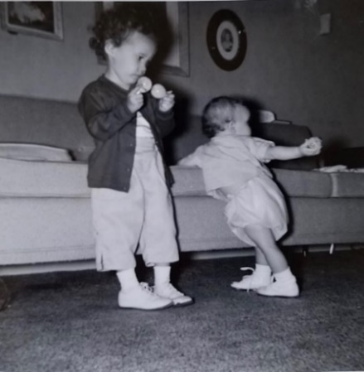 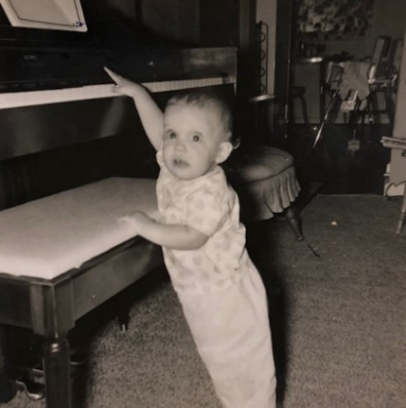

She’s learning to walk and gets more discontented than when she was only crawling. Lisa can just barely reach the piano keys and does love to push them.

We were glad to have your letter yesterday. My writing is coming along OK. The company in Topeka had sent my glasses on here and they were here when we arrived. They make my night driving more safe and easier. Tomorrow morning Ruth has a coffee for Jean Jones, the wife of the new assistant pastor. She is about Ruth’s age and he is younger than myself. I may come home in the morning and babysit, since we can’t afford to hire anyone.

Ruth had evangelism committe meeting last night and the Jones stopped by a few minutes beforehand. We may have them over to eat sometime. They have a baby 1 month younger than Lisa. Lesle has some cold today and is pretty tired. I went to bed early Mon night and stayed home yesterday morning as was so tired. I apparently had a touch of virus which I gave to her. I feel OK now. Mon morning I worked and then came home in the afternoon. We rested some and then I dug a hole for a little barbecue pit. We cooked hamburgers and had a picnic supper outside. We used your chair and wished we had the other one.

Sun morning we all went to s.s. and church. We were on time for s.s. since Lisa got up so early. Sun afternoon Deloris came over from Lawrence (she’s attending the speech camp in conjunction with the big music camp). We got a lady at church to babysit and all went out to the Wyandotte County Lake where the department had a picnic. It was Dr. Walaszeks birthday, also. We had never been out there and enjoyed it very much. We drove Deloris directly back to Lawrence from the lake as we were already several miles west of town. We got home about 10:30.

Last Sat morning I worked as usual. Lesle and Ruth made their usual trip to the library. I guess we were home all the other evenings since I last wrote. The last few days have been nice and cool again. We used the air conditioner once last week and found that we have to unplug the refrigerator so the fuse won’t blow when running it. We have the kind of fuses that can’t be changed to a different size easily. Tell Aunt Clara, M.J. Bill, Jimmy and Uncle Clyde hello.

**7-12-60 – Tues morning 8:30 –** Today is cloudy and it has rained some this morning but it is still supposed to get into the 90’s. Yesterdays 3 hours above 100 made it our hottest day, so far. Our air conditioner helps a lot in the living room but isn’t strong enough to cool any other rooms. Lesle is pretty much over her cold, although she coughs a little yet. However Lisa now has it and had a real hard night – with the heat and her coughing. She was so tired this morning that she’s now back in bed.

Thurs the girls have their Dr’s. appointments and I have an insurance examination on Fri. The insurance man was out last night and I said I’d take out some more. We were glad to have your letter yesterday and to hear about everything. Sun morning we all missed s.s., because of Lesle’s cold, but went to church. Lesle stayed in church the longest and most quiet she’s ever been. We sit in the balcony (no “bawl room”) so we can easily get out. We were home the rest of the day – took a little walk in the evening.

Sat morning I worked at the building and in the afternoon Ruth went to the library by herself because of Lesle’s cold. We ate in the backyard Sun evening. Last Friday morning was Ruth’s coffee rather than the day I said in last weeks letter. Grandmother made marks in the margins on either side of the next paragraph. Ruth is up seeing the Dr. this morning. It looks like you’ll be having another grandchild in late Dec or early Jan. This is an unexpected, but not unwelcome event for us. I guess that’s about all the news for now – enough? Tell Aunt Clara, Uncle Clyde, M.J. Bill and Jimmy all hello. Lesle has some marbles she wants to give to Jimmy.

**7-19-60 – Tues 4:15 PM –** I’ll write this at work and we’ll mail it on the way home this evening. As I’ve mentioned before, Ruth and the girls always walk up and get me in the evenings. Occasionally we’ll stop at a drive-in on the way home. The last couple of days have been cooler again, after several hot ones. All in all this has been a mild summer, so far. We’ll have to fix your big fan some way so the girls won’t get in it when we’re there. The Laidigs have air conditioning in Oberlin.

We were glad to have your letter yesterday, and hope your knee and leg are better. We were home yesterday evening and will be for most of the week. Next Sat evening we’ll have a baby sitter and go to a party at our s.s. teacher’s house. It will also be a farewell for one of the families in our class that is moving away. The way it stands now we’ll leave here on Sat July 30th and drive to Oberlin. Sun the 31st is the golden wedding anniversary open house for an aunt and uncle of Ruth. Unless I hear differently I’ll be working that week for Ted Addleman. On the following Sun Ruth will play the organ and I’ll sing a solo at the church service. We’ll leave after that for Hutchinson.

My thesis should be largely done before we leave, with only minor details left to finish. Yesterday evening a doctor came by to check the girls for some life insurance. The money from Aunt Martha’s house (I suppose M.J. and Bill had a check) came and couldn’t have come at a more appropriate time. I paid back the $100 I had borrowed from the Medical Center student loan fund and will be able to pay for the insurance.

Sun morning we all went to s.s. and church. There was an all church coffee after church and Ruth, because she is on the evangelism committee, helped serve and also got up early Sun morning to bake some cookies. We were home the rest of the day Sunday except for a walk.

Sat morning we all went shopping and got new shoes for both the girls. I came to the building a bit in the early afternoon and then home while Ruth went for groceries and later with Lesle, to the library. In the evening we went to see “Annie Get Your Gun” at the Starlight. We had a lady from the church for the babysitter. She takes care of the children on Sun morning and Lesle gets along pretty well with her.

The girls had their regular Dr. appointments last Thurs and were OK. Lisa is eating better after being upset awhile with that virus. Ruth feels pretty good but gets somewhat tired. I haven’t voted recently but voted Republican the last time I did. Tell Aunt Clara, M.J. Bill Jimmy and Uncle Clyde hello. We’ll try to get to Newton and Wichita while in Hutch. I bought the Jayhawker M.D. annual today.

**7-27-60 – Wed 7:00 PM –** I meant to get this written yesterday but didn’t get to it. The last few days have been hot again, after several cool ones. At least we haven’t had any real long hot spell, so far. Ruth’s intestines have been bothering her recently so I come home at noon to help out. She is to check again with the Dr. Friday if the mineral oil doesn’t help. She had the same trouble with Lisa but it was near the end.

We were glad to have your letter yesterday and hope again that your knee is feeling better. If we have room we’ll stick in our fan although its not much good unless you’re right upon it. We had the air conditioner on all yesterday and evening but only this afternoon as it was a bit cooler. We had a letter from Mrs. L today and she said they would use us for the music next Sun rather than a week from Sun. Hencefore, we may leave late Fri (afternoon) and stay in a motel that evening and on to Oberlin Sat morning. That way we’ll have a little time to relax and practice beforehand. I’m not sure when we’ll leave Sun. I had said we’d leave right after church but I’ll write Murray and if he doesn’t need me until Tues we might not leave till early Mon. As you said I work for Cad Hayes the next week after Murray. He might want me a 2nd wk also.

I’ll take Lesle and we’ll go mail this after a bit. Lesle is essentially “half” trained. We bought her a little Car John for traveling. We were home Mon and Tues nights. We all went to s.s. and church Sun and were home the rest of the day. Sat morning we all went downtown on the bus (we had promised Lesle a bus ride) shopped awhile, ate at a cafeteria. We were all exhausted but I guess it was worth it.

Sat evening we had a babysitter (a college girl who works for Dr. Walaszek this summer) and then went to that s.s. class party out at our teachers. That was nice of your renters to invite you to their party. I might be able to paint some while we’re there. The annual was $5 but don’t bother to send it now as we’d be gone before it would come. Lesle is printing M’s L’s etc. right now. I don’t think we did much last week from the time I wrote you until Sat. Tell Aunt Clara, Uncle Clyde, M.J. Bill and Jimmy hello

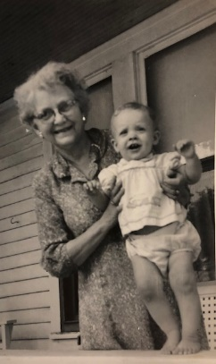 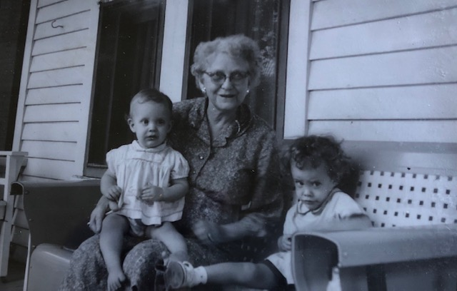 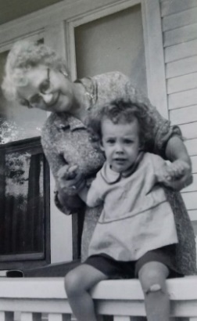

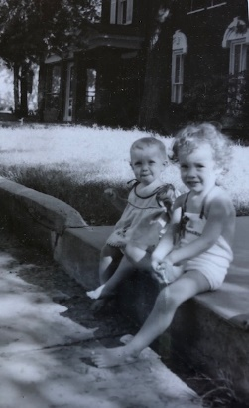 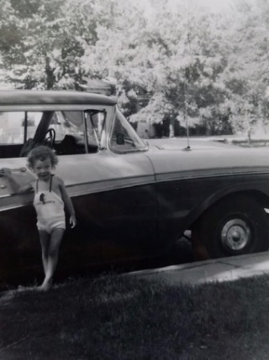

August in Hutchinson.

Lisa with Grandmother “calling for her mommy.” Lesle with Grandmother “she didn’t need any help.”

**8-25-60 – 1:15 Thurs –** We had a fine trip back arriving here at 9:00 PM and that included a stop at the grocery store. We had supper at the Emporia turnpike restaurant. It wasn’t too hot riding and Ruth drove all the way except for a stretch the other side of Newton. The girls were asleep when we went thru Newton so we didn’t stop. Ruth and Lesle are at the grocery now. I went to the building this morning and will go back again. Thanks again to you and Aunt Clara for everything and we’re glad we got to go. Lesle remembered the Kafrecorn Sp? as we drove to Newton. Read this to Aunt Clara and have a good trip.

**No Date – 11:00 AM –** We were glad to have your letter and trust that everything is going fine and that you had a good trip. It has been real hot and humid here since we got back. Our living room doesn’t cool off very well and we hate to run the air conditioner all the time. I have practically finished the first rough draft of my thesis and am also applying for that other fellowship I mentioned. I was glad we came back early as Dr. Peters was back and he could vouch to the others ha! that I was back that week. All the other staff members attended the meeting in Seattle.

Tonight we’re having the college girl, who’s working in the department, for a baby sitter and we’ll go to the Starlight for the final show “The King and I.” Are M.J. and Bill coming down for the American Royal. Last night we had the girl babysit and we went out to G.E.M. We hadn’t been out for a time and got some drugs (that we forgot to get in Hutch) toys and other things. We probably didn’t save too much by having to hire a babysitter but it is nice to shop occasionally without the children. Last Sun we all went to s.s. and church the girls were tired before they went so had a hard time as usual. Lisa woke up at 5:30 one morning but we make her go back to sleep awhile longer (till about 7:00) before we give her a bottle. Of course, Lesle wakes up at about the same time but we’ve been making her sleep longer too. Lesle had a touch of cold and yesterday wouldn’t take a nap. She was so tired that she went to bed real early. As a result she was up once after we came home from GEM and then at 5:00 this morning walked in and said her cold was better.

We got the Sifo wooden jigsaw type puzzle Hickory Dickory Dock for Jimmy Christmas so you might check sometime to make sure that he doesn’t have it. We have to get Christmas things done early since “Pedro” will interfere. I talked with one of the fellows here and he said quinine was what one of the “big” Drs. here used for leg cramps. You can get quinine capsules 5 grams without a prescription and would take one at bedtime. I’ve seen Dr. Parne’s prescriptions for quinine to be used for leg cramps and you could check with him if you wanted too. You might cut out an aspirin tablet every time you took a quinine. Don’t cut out all your aspirin. Again, hope you have a good time and let Aunt Clara see this.

**9-9-60 – Fri noon –** Today is much cooler and it is rainy. This is the coolest day we’ve had since we got back and it’s a welcome relief. We’ve had the air conditioner going during the afternoons and evenings for the past week. We were glad to have your letters and phone call from Olathe. I trust the rest of the trip went fine for you and I know you had a good time in Indiana. We gave Lisa a little horse for her birthday today. She rides it and pushes, but can just barely reach the floor from it. Lesle likes it too of course.

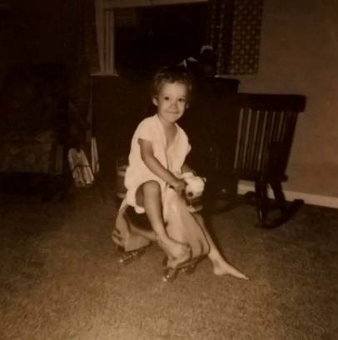

Lesle on *my* horse.

Lisa had her regular Dr. appointment on Wed and she has a touch of bronchitis and ear infection. She’s taking some antibiotic and seems in a pretty good mood today. We’ve all had touches of cold but are about over it. The hot weather made us all pretty tired so today is a relief. I hired our part time secretary to type my thesis. She’ll type a first draft this weekend that’ll be used for final corrections. Tues night we had Jeanie Leicht (the girl at the department) come (she came down with me and stayed for supper) and we went to church, Ruth to evangelism committe meeting and I to choir practice. Last Sun we missed s.s. and church because of our colds. I guess we all needed the rest. A week ago last night we had Jeanie come and we went to the Starlight Theater to see “The King and I” (the last production). You may remember the time the Rotarians went to the movie with their women folk. Tell Aunt Clara, M.J. Bill Jimmy and Uncle Clyde hello. M.J. and Bill were here one yr ago last night (4H meeting) and left one year ago today without getting the word about Lisa.

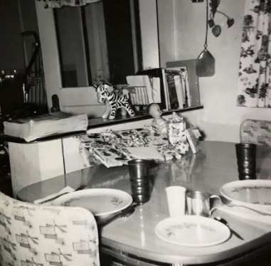 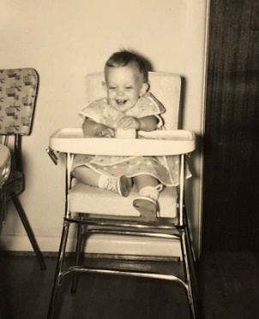 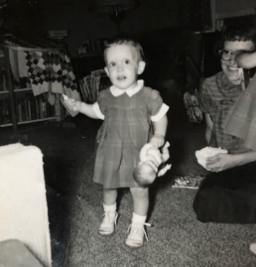

Lisa’s 1st birthday – 9-9-60

**9-14-60 – Wed Noon –** I’m home this noon so I can write this and Ruth and Lesle can go pick up an order at Wards. I come home at noon about half the time. Lisa is saying daddy and mama real well and gets the name with the right person most of the time. Lesle knew many more words by this age, but each one is different in their development. Lisa is doing real well on her walking and gets clear across the room by herself. Lisa also says baby, here, hi, dirty and no and yeah. Amazingly, Lisa weighs less than Lesle did at the same age. She’s just a different build which makes her seem fatter. Lisa says “thank you” for her pretty locket. Its heart shape makes it easy to distinguish from Lesle’s which is round. Grammy and Grandpa are sending Lisa a rocking horse like Lesle’s – it has their names on it. The famous little rocking horses. Mine is currently sitting on top of the armoire in my family room ☺

The last few days have been rather chilly when compared with that hot spell. It has been a welcome relief, however, from the heat, and we all have more energy. We were glad to have your letter yesterday with all the enclosures. Why don’t you plan on coming up some week-end before we leave Kansas City. We’ll probably be going to Lawrence Sat the 1st of Oct. Mr. Laidig has tickets for the football game and while we may not go to the game we’ll probably go over. We want to see Judy Laidig (John’s girl) who’ll be a freshman (she’s real smart). John, of course, is a KU graduate and was a Summerfield Scholar (like Wilson O’Connell was). The Watkins Scholarship (the one Mom had) for girls is similar.

We’d like to go to Chicago to find a house before too much longer, but that wouldn’t necessarily be on a weekend. The way it looks now we should get away between Oct 15th and the 1st of Nov. Glad your leg is feeling better and I’d try that quinine sometime for the cramps. Lisa got over her infection OK – she was never really down with it. We’re all free of colds right now. Ear infections can lead to ear trouble later but, unlike when I was little, antibiotics make it much less likely (they didn’t have antibiotics before the war).

Last night I babysat and Ruth went to choir practice. Sun we all went to s.s. and church and rested in the afternoon. At 5:30 we went on a picnic with Larry and Velda Brown (he’s a social worker and they go to our church). Afterwards we got the kids ready for bed and went to their house to have popcorn and watch TV. The girls both went to sleep at their house. We had had them over last New Year’s Eve. Last Sat morning we went down and registered to vote – which we won’t get to do if we’ve already moved. We then went to the library and did some shopping. I went to the building awhile afterwards and Lesle and I took some typing out to the lady who is typing my thesis. She’s a part time secretary in our department and shouldn’t charge too much. I’m ready to start my final corrections but it has to be approved by the staff before it is bound. I hope to do a few more experiments before we leave, to complete some papers to be written up later, if I have time.

If you have to teach on the weekends you could come in the middle of the week. We had a man come to the house to take Lisa’s one year old picture. We took several snapshots of her birthday. The suit came OK, and I’ve worn it several times, I’ve been wearing the coat to work this week since its cooler and I wear a tie or buttoned collar all the time. Guess that’s about it. Tell Aunt Clara, Uncle Clyde MJ Bill and Jimmy hello and let them read this if you like.

**9-22-60 – Thurs noon –** We were glad to have your letter and to know that your leg is better. Today is some cooler and cloudy but no rain for some time. I finally got the grass all burned that we raked up after the boy mowed it. I doubt that I’ll need to mow it again before we leave. Tonight is choir but I have the seminar in the morning so I’ll stay home and let Ruth go. I guess we’ll have my birthday dinner tomorrow night. Sat we may go out to GEM since Mrs. L needs some more medicine, and I think I’ll give in and buy a new electric razor. The one I have now has been in use for 8-10 yrs, and that old one I brought back isn’t any better. The Laidigs will be here the week-end of the first. Mr. L has tickets for the football game. I don’t know whether they’ll come here first or we’ll meet them in Lawrence on Sat. I’d like to attend the Pharmacy School open house that Sat morning.

Mrs. L said she’d stay over a few days so we could go to Chicago to look for a place to live. We’ll go on the train and try to borrow Al Poisner’s car (intern there who used to work with us). If we find something we might have to pay rent for a month in advance since we won’t get clear away from here until about Nov 1st. Ruth wants to stay the first week in Nov so we won’t miss voting. You lose your right to vote as soon as you give up your residency.

The Public Health Post-Doctoral Fellowship is $4500 plus $500 for each dependent – that’ll be $6000 for us and $6500 if I have it renewed a second year. If the research goes real well I’ll probably stay a second year, unless a good job opportunity comes along. Last Tues night we had a girl from church baby-sit while I went to the graduate course class and Ruth went to circle. Sun we all went to s.s. and church and were home the rest of the day except for a drive to the post office. Last Sat afternoon Lisa and I went with Ruth and Lesle to the library and then some shopping. You’d enjoy seeing Lesle at the library since she gets so excited.

Lisa walks real well and is trying to run so much that she falls a lot. She jabbers a lot but doesn’t say much except for the words I last reported. Thanks for the picture. This Sun afternoon Ruth and I will call for Communion Sunday and then there’s an open house out at Dr. Huggins. Dr. Deane Calvert and his wife (new instructor) returned the mattresses they had borrowed, last Wed and stayed awhile and visited. I’m adding some more in my thesis so have some more writing to do. Ed has been paying me $500 a month since July 1st so the money should come out just about right to cover moving etc. Glad Jimmy could stay with you awhile. Hope Aunt Clara, M.J. Bill Jimmy and Uncle Clyde are all OK and you can pass this on, if you want.

**9-?-60 – Thurs noon –** I’m home for lunch and will write this now. The days have been warm and the nights cool as it usually is at this time of the year. It was cloudy this morning but is clear now. Mr. Blim, our choir director and organist, has resigned after 38 yrs of service. He is dean of the K.C., Missouri Jr. College and is just too busy. The choir attendance has fallen off some this fall and he just wouldn’t have time to build it up. His son is our pediatrician.

Tomorrow night we’ll eat out, get gasoline and go to the library - we’ll be in Lawrence Sat. We’ll have to leave as early as possible Sat morning since we’re to meet Mrs. L around 9:30. Mr. L has a meeting and the Pharmacy School Open House is at 10. The football game is sold out (42,000) since KU has a good team and is playing the #1 team, Syracuse. Deloris, Danny and a friend are also coming. Mr. L called last Mon morning to make sure that everything would be OK. They’ll all stay here Sat night and then Mr. L and the kids will go back Sun. Mrs. L will stay while we go to Chicago. As I said, we’ll go on the train late Sun night and hope to be back by Tues night. I probably won’t write again till after we get back although I might drop a card from Chicago.

The Laidigs have made their reservations for the trip to Rotary International. Mr. L is the uncontested candidate for district governor this next year, but they don’t pay all of his expenses to the international convention. Last night Ruth went to Womens Association and I stayed with the girls. I see where GEM (big “discount” house) just opened up in Wichita. I wonder if M.J. and Bill will join. We went out last Sat morning and will probably go again before we leave. Tues night was my class and we were home Mon night except Ruth went for groceries.

The girls are fine and Lisa talks some more and is into everything. Glad to have your’s and Aunt Clara’s birthday cards. I got 2 pairs of socks from Lesle and a tie from Lisa. Ruth gave me a white shirt and they all got me a new heavy sweater. Last Sun we went calling after church and then out to Dr. Huggins for open house. Had the girl from church baby sit in the afternoon. Sat afternoon we all went to the library. Glad to have your letter and nice Aunt Margaret can come. The 10th or 17th would probably be best for coming. Hope your legs better. You can show this to all and tell Aunt Clara, Uncle Clyde, M.J. and Bill and Jimmy hello.

**10-7-60 – Fri noon –** I’m home this noon so will try to get this off. Our weather is about the same, warms up during the day and cool at night. A week ago Wed evening (forgotten when I wrote last) Ruth had association meeting and I babysat (guess I wrote that). Thurs evening we all ate at the restaurant got gasoline and went to the library. Lesle’s children’s room was closed so I had a time chasing the kids around the stacks. Sat morning we got off as early as we could and went to Lawrence. Ruth and Lesle met Mrs. L. at Bailey (my old pharmacy and chemistry building). Lisa and I went to the School of Pharmacy open house at Malott Hall. Visited some with Dr. Wenzel and met the Lilly salesman from Hutch. Ruth, Lesle and Mrs. L shopped downtown awhile and then the Laidigs ate at the union while Ruth and Lesle came back to Malott where we all had lunch at the open house. Mr. L, Deloris, Danny and a friend, and Judy Laidig (John’s oldest girl at KU) all went to the game while we watched from the hill to the South. Mrs. L and ourselves visited the new Presbyterian Student Center before she went downtown and we went to the game. It looks like the Baptists have made one of those close-in houses into a student center.

After the game we all met at the union and visited with Judy awhile. She likes KU fine. (She’s in the genius category.) We all came back here to K City and ate at a restaurant. The two boys slept in sleeping bags in the kitchen, Deloris slept in the girls’ room and the Laidigs in the living room. Sun morning Mr. L and the kids drove back to Oberlin and Mrs. L went to s.s. and church with us. Big crowd for the communion. We rested Sun afternoon and got ready for the trip to Chicago. We left on the 1:10 AM train and got in at 9:00 AM. We took a cab right out to the med center. Dr. Abood had a local paper (Anstinite (?)) with some places marked. The paper had come out the Wed before so all the good places were taken. He took us to lunch at the union and we spent the rest of the afternoon calling and checking maps etc. Al Poisner took us to dinner (he’s an intern) as his guest at the cafeteria. Afterwards we saw where he stays (he’s single) and then he drove us out to see some apartments. Nothing came of that for sure so he took us by the Aboods and then to Dr. Abood’s mother-in-law where we stayed all night.

The next morning (Tues) we went to the Aboods where Mrs A had a group of women in. Before and after lunch Mr. and Mrs. Wuchner (Abood’s mother-in-law) drove us around to 15-20 realty companies. Just missed getting a small house (no yard) with lots of inside room but some people beat us by a few minutes. Tues night we ate at the Aboods. Wed morning we got the first copies of the Anstinite, rented a car and got right out to see one of the few (8) houses listed for rent. The man promised to hold it for us till 2 as we wanted to see another. We never did get to see the other house (couldn’t catch the man who was showing it) so went ahead and took the other one. The house is in Franklin Park, Ill, 30-40 minute drive to med center, 4 rooms about the size of our 4 only with an additional bedroom, which we were holding out for. However, it has a full basement, nice grass, good neighborhood, fenced in backyard (not as big as ours now), swings in yard, some flowers, is brick and fairly new, $140/month, no garage. We took the elevated down to the loop and got back at 1:00 AM yesterday morning.

Last night Mrs. L stayed and we went to choir practice. She left early this morning on the bus. Let us know whether you’re coming next week or the following. Franklin Park is only 130 miles from Madison. If Ruth is able maybe you folks could come up to our house and if the weathers good we could go on to Madison. That should satisfy Aunt Nellie and would be about the last we could get away until after the baby is born and the cold weather is over. If M.J. and Bill couldn’t get away, maybe you and Aunt Clara could come. We will have plenty of room with the extra bedroom. You can show this to M.J. and Bill and see what they say and I’ll write her sometime. We, of course, won’t get away Christmas at all since the baby is due anytime then. Tell all hello.

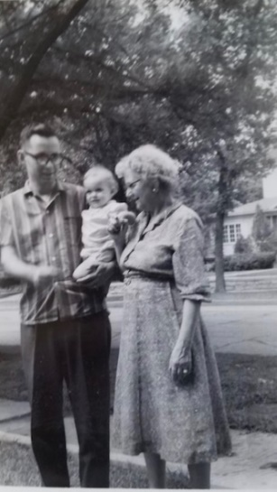

Dad, Lisa and Grandmother

**10-27-60 – Thurs noon -** I’ll write a letter later. (This is a postcard.) Everything is fine here. The weather has been warmer the last few days so the girls have been coming up to meet me. Glad to have your letter and sorry to hear about Mr. Collins. We all had dinner at Bob Legg’s Tues night and tonight is the farewell party for Mr. Blim the choir director. Sat night is a s.s. class bowling party. Dr. Peters read my thesis and I’m making final corrections this week. We cut out a lot that I’d added in but I was glad to get it written up since I’ll want to publish it sometime. Hope everyone there is OK.

**10-31-60 – Tues 12:45 –** We were glad to have yours and Aunt Clara’s letters. You, of course, can read this to Aunt Clara and we’ll write her later. We did not have any snow here but it was quite cool as it rained most of the time Sat and Sun. Today is warmer and clear. We hope it doesn’t snow before we leave. Sorry to hear about Mr. Simpson, for some reason I can’t picture him in my mind.

You can do what you want with my old letters. I imagine the best, as you say, would be to just keep the most important ones. They would be interesting to read again someday. They would just about represent a complete diary of all the time I’ve been gone from Hutchinson.

Hope your leg doesn’t get any worse and Aunt Clara’s toe gets better. We’ve been pretty well and have avoided any bad colds so far. This afternoon I have to help Joe Underwood (former graduate student who quit and works as a technician) move some furniture. He helped me quite a bit when we moved into this house. It has been cold enough that our walls are getting damp and the mildew is forming. We’ll be glad to get away from that. We have to be out by the 15th. The salesman was here this morning and it will run $400-500 to move plus lots of minor expenses. It will cost us double rent for one month. The man in Chicago wants 2 months rent at the start so I’ll have to pay him $350 before we ever move in ($70 for last half of Oct and $280 for 2 months).

Tonight is the graduate course and choir Thurs night. Last night Ruth went to the library and Lesle and I had to go to the door a couple of times for trick or treaters. She got all excited. We only had about 4 or 5 groups since our house looks kinda dark with the shades down. At the party last Thurs night following choir practice they gave us a record. The party was really for Mr. Blim (retiring) and his wife. They gave him a pen and pencil set and her a brass colored waste-basket. We were home Fri night and Sat night had a babysitter as we went to the s.s. class bowling party. We were so late that we only got to bowl one game but we didn’t mind. Ruth beat me! Afterwards we had refreshments at our teachers. They had a coffee maker (going away gift) for us. Since we already have one they said they’d exchange it. We all went to s.s. and church. Tell all hello.

**11-15-60 – Tues 9:45 PM –** I just returned from the graduate course and will write this while I’m listening to the election returns. So far it looks like “our candidate” is not doing so well. (Nixon?!) Tonight is a little cooler after being warmer today. We have not turned the furnace on because of Lisa, and since it was giving us trouble when we turned it off last spring. We can heat the house with the oven and the little electric heater about as well as we can with the furnace. Sounds kind of dangerous. Ruth has been working hard cleaning walls the last few days but as soon as they’re cleaned the moisture condenses again and the mildew is soon apparent.

We, of course, were sorry to hear about Bill’s father. I suppose you have your hands full with Jimmy although Bill and M.J. may be back by the time you receive this. We were also sorry to hear about Mattie Kent. Was her trouble a result of her fall? I think you wrote that she had fallen or something. Our address will be 3021 Hawthorne, Franklin Park, Illinois.

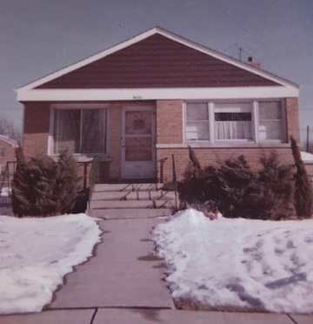

My final oral is set for the 18th and the movers are scheduled to come on that day. Therefore, we’ll have to start driving that evening. We probably won’t go far and will stay in a motel. Since the furniture won’t get there till Sun or Mon we won’t be in any great hurry.

I’ll be making my third trip to Lawrence tomorrow. My thesis will be bound by tomorrow afternoon and I’ll deliver the two copies to the graduate office. I have four other copies. One of these is yours but I won’t be able to send it until after the oral exam since I’ll need it to let some of the staff members read. There is a copy of his thesis in Park Forest if anyone is interested in reading it ☺

Fri afternoon – Sorry I didn’t get this finished and off. I’m staying late this noon waiting for Mrs. L and her mother to stop by. Grandmother has been in Miami, Florida 2½ months and was planning to spend the winter but got restless to get back. She’s 94 now. Mrs. L drove here yesterday and flew down. Their plane was due back here at 10:30 and they were going to eat before coming out. They do not plan to stay all night.

We plan to get the packing finished this weekend so I’ll have some review time next week and Ruth can finish some sewing etc. Ruth went to our final choir rehersal last night and I stayed home with the girls. Wed morning I helped around here a bit and we left for Lawrence at 11:00 AM. We had written Judy Laidig to meet us at noon if she could and we’d eat with her. She was there and we ate downtown at a restaurant. We just barely got her back in time for her 1:00 class. We then went downtown and I visited one of my old classmates at a drugstore while Ruth went shopping. Lesle took a short nap and Lisa hardly any at all. I picked up my bound theses and took a copy to Dr. Samson (my minor advisor) and one to Dr. Wenzel. I didn’t have to give one to Dr. Wenzel but I think he appreciated it. He says the’re trying to start a new graduate program somewhat related to pharmacology and would need a new man if it goes through. Therefore, there would be a possible job opportunity if he can get the program approved. We ate supper at the Lawrence turnpike restaurant on the way back. The girls were very irritable because of their lack of sleep.

Yesterday afternoon I drove to Lawrence and back to take two signed copies of the thesis, and some other things, to the graduate office. Last Mon Lesle and I drove to Lawrence to leave the theses to be bound. Last Sun I stayed home with Lisa during s.s. while Ruth and Lesle went. Ruth came back and got us for church. Ruth and Lisa watched the service long enough to see the infants baptized and then stayed in the parlor. We kept Lisa out of contact with others since she was having quite a reaction to her small-pox vaccination. They both have had touches of cold recently.

I borrowed off my Investors Certificate to help cover moving. If I hadn’t had that (it’s the same as taking back money you’ve already paid in) I would have had to borrow on some insurance. The man estimated $433 for moving but I’m sure it’ll go over $500 since he didn’t see a lot of our books and things. Ruth will write Aunt Clara about the girls. Tell all hello. We voted last Tues. We promised we’d be out of here the 18th.

**No Date – Wed morn –** Mom writes – Dear Mother, We’re here, but so far no furniture. We’ll have a phone in a few min. so will have a no. shortly. The furniture should arrive today – we hope. We stayed at Maurine and Bill’s last night. Aunt Margaret was there, so we all got acquainted. So far we’ve only stayed 2 nights in a motel (thanks to our K.C. minister). We stayed at Carrollton, Mo Sun night and at Bloomington, Ill. Mon night, but even so, the kids were terrors. We got your card yesterday shortly after we arrived. Carroll and Lesle are just back with a sponge and shelf paper, so better get to work now. Will write more later. Telephone no. GLadstone 1 – 1859.

**11-27-60 – Sun 7:00 PM -** Grandmother writes in upper left hand corner “First letter from Chicago”- I, of course, meant to write earlier but its been a busy time. It is cloudy and rainy this evening but is still above freezing. It is supposed to get cooler later this week but so far its been one of the warmest Novembers they have had here. Dallas Musgrave called this evening and will be over tomorrow evening. He works at a downtown bank. He quit college before finishing. The girls are crawling all over me as I try to write this. The girls are somewhat less irritable and are eating better now that they are back on a more regular schedule and are getting more sleep. Lisa is cutting some teeth and doesn’t eat quite as much as she did. It gets dark so early here that they take longer naps.

We were glad to have your letter yesterday. I believe you wrote it Fri. Mail apparently gets here about as fast as to K City. This morning we went to the Elmwood Park Presbyterian (Lisa just crawled over me) Church. It is some smaller than the church we’re from and seemed fine. It is about a 15 min drive but several of the members live in Franklin Park. There is a new small Presbyterian Church in Franklin Park.

It was nice you could all be together for Thanksgiving and we, of course, wished we could have been there. Anyone is welcome to come visit us at any time. We’re only about 15 min drive from O’Hare International Airport where all the jets and many of the other planes land. When the wind is right there is almost a constant stream of planes going directly over our house. Yesterday morning we went shopping. There are plenty of all kinds of stores a short distance away. Ruth and the girls walked to a Kroger store last Fri. We may go to a pediatrician that is within walking distance. Ruth would like your recipe for asparagus casserole. We’ll try to line up Ruths Dr. this week.

Aunt Margaret is leaving Hinsdale Tues so I’ll try to call her before then. We’re ordering a new rug for the living room and will get some curtains and chests for the girls after the financial situation is improved. We had to leave our bookcase bricks at the Moyes in K City because the car was over loaded. As soon as the rug comes we’ll get the living room in shape. Love to all.

**12-4-60 – Sun 5:30 –** This letter is written in pencil. Argh! We’ve been waiting for Dallas Musgrave to come over. He was supposed to come last Tues night but there was just enough snow to make it real slick driving and he decided to wait until today. We told him to come early enough for supper if he could. We bought a green sisal rug ($60) for the living room and we need Dallas to help move the piano etc. so we can get the rug down. The floor is so heavily shellacked that the slightest movement of a heavy object leaves quite a scratch. The rug is of course not of soft carpet material but has a raised design that makes it appear just like a rug. The rug didn’t come until Fri and we can’t get the living room fixed until the rug is down. I guess I told you we hope to get some curtains and other things later. Ruth painted some this last week on the bookcase boards and the nursery chest that you gave us.

Now 9:05 – Dallas never came this evening so I guess we got our connections mixed up some way. The weather has been warmer yesterday and today after some snow and several real cold days last week. Tomorrow is due to be warm but colder again tomorrow night and some snow. I’ve added some weight to the trunk of the car so we’ll get better traction on slick streets. Ruth has her first appointment with Dr. Vasil Truckley Tues evening at Presbyterian St. Luke’s Hospital (just North of the med center). He is the Dr. that Mrs. Bill Jones (assistant minister at Roanoke Presbyterian in K.C.) had - she liked him very much. This hospital is supposed to be pretty good and much better than the U of Ill med center.

We all went to church this morning but were a few minutes late. As I may have told you they have an adult s.s. class but there is no nursery at that time. S.s. comes during the church hour. We won’t try to join the choir until after the baby is born. We’ve been home the rest of the day today but I’ll take this out later to mail. I put up some curtains this evening.

Yesterday morning we went shopping in Oak Park (where Dr. Abood lives and where we stayed that time we were here) and with some more shopping close by we didn’t get back till about 3:00. Ruth went out for groceries and some other things in the late afternoon. Ruth made candy this afternoon to send to Harold and Lorraine Brownfield in Turkey and Delbert Musgrave in Turkey. Last Tues morning Ruth called the Lesters and got to talk with Aunt Margaret before she went back home.

Snow flurries occurred during the day last Tues and it was very slick all the way home. I tried another route than the Congress Expressway since Congress has some inclines and I didn’t have any extra weight in the trunk. The route I took was very flat but it took me almost 2 hrs to get home (15 miles). Streets were fine Wed.

We received your letter yesterday, so they seem to get here about as fast as to K City. It is easier for me to write you on Sunday. I don’t like the traffic jams and distances of the big city but otherwise everything is fine. We plan to take the girls downtown sometime. They have a bus service from out here on downtown. We like our house fine – it’s the nicest of the 3 we’ve lived in. The basement is so nice to have. The electric dryer is now hooked up – Mr. Gerding had to have an electrician run a new line.

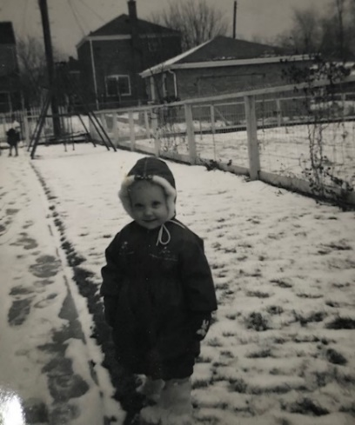

Lisa in the snow in Franklin Park. Is that a tiny Lesle in the background?

My work is OK. I’ve been talking with all the people and getting oriented but should get some lab work started this week. Yes, I went to work a week ago last Fri. I may not get my first check until after the 1st of January. I should have a check from K.C. the 15th of this month, however. Our tel GLadstone 1-1859. Dallas has a room on the northwest side and rides the el to the bank downtown. I knew of Charles Remsberg as a boy.

We have subscribed to the Chicago Daily News rather than the Sun-Times. We looked at several apartments like they probably live in. I guess its best we not try to go to Madison now. The weather is unpredictable and the baby is not much more than a month away. It’s been running me 30-35 mins to work in light traffic and 50 in heavy. You can share this with Aunt Clara, M.J. Bill and Uncle Clyde.

**12-11-60 – Sun 5:00 PM –** Dear Aunt Clara, This will be the letter that we promised you before we left K City. Pardon the pencil but our pens seem to be out of order. You can share this with Mother like I trust she always does with you. Our letters, of course, are always meant for everyone. As is usually the case when I try to write a letter at this time the girls decide they should be right on top of me helping.

As was the case a week ago, snow flurries are predicted for tonight and tomorrow. The snow did not materialize a week ago. So far we’ve had just that little bit 2 weeks ago. It was just enough to make the driving bad, however. I hear that there’s been some snow out your way and there’s been quite a bit all around us, so I guess we’ve been lucky. We keep our eyes on the weather since we might have to make a fast trip to the hospital someday. Our doctor says he’ll help things along some if everything is just right. We hope it works that way rather than a fast trip at an inappropriate time. We’re 30-50 minutes from the hospital depending on the amount of traffic. The minister called on us one evening last week and offered to help in an emergency. If Ruth needs help during the day she’ll probably call him first since he could get her before I could. The Lesters have offered to take the girls the first day so we may call on them also.

Ruth’s hospital is Presbyterian St. Luke’s. It is a few blocks from where I work and is said to be a very good place. Much of the building, including where Ruth will be is only about 2 yrs old. All of the medical schools and hospitals there are called the West Side Medical Center. All together there are 6,000 beds which makes it about the largest concentration of hospital beds anywhere in the country. There are also 3 medical schools: University of Illinois (where I am); Loyola University (catholic) and the Chicago Medical School. The other 2 medical schools in Chicago are Northwestern on the north side (Aunt Martha’s) and the University of Chicago on the south side (my dad’s school). My graduate school advisor graduated from the U of Chicago. We’ll try to visit the campus sometime while we’re here. The last time I saw the U of Chicago was in 1945 when we were on the way to Wisconsin.

The U of Illinois School of Pharmacy is just across the street from where I work. It is a fine new building with escalators. When I start looking for a permanent job I plan to consider a teaching job in a pharmacy school. I always tell people that I have a close feeling for pharmacy since I grew up in a drug store from the time I was 12 years old and then went as far as my masters at the KU School of Pharmacy. I often tell the story of how I grew up in my Uncle’s drug store.

We are gradually getting more settled. Our rug is down and looks pretty nice. Most of the curtains are up and the bulk of the painting is done. We still have to buy some bricks for our bricks and boards bookcase. We had to leave our bricks at our K City ministers house since the car was overloaded and we had failed to give them to the movers. It is sure nice to have a good, dry, big basement. The girls play down there quite a bit.

The Lesters are coming for dinner Thurs and next Sun night we’re invited to dinner at some of Ruths friends (former Oberlin, Ks people). Lisa has had a touch of cold for some time now so I stayed home with her this morning while Lesle and Ruth went to church. Last night we had our first baby sitter and went to the couples’ club dinner and monthly meeting. It was a talent show. The couples club meets once a month for dinner and a program and consists of all different ages. There were almost 100 last night.

Yesterday morning we opened our account at the Franklin Park Bank and did some other shopping. This afternoon Ruth and I painted. Ruth is holding up pretty well but she has quite a few Christmas things yet to do. We don’t have a tree yet. Lesle should get quite a bit out of Christmas this year and is talking about Santa Claus the lights etc. We plan to have the piano tuned soon. Are you going South later this winter? We’ll probably wish we were South after the snows come. Hope everyone is fine there and tell all hello. We haven’t received a letter from Mother this week but may get one tomorrow. Hope you can come to Chicago sometime.

**12-25-60** – Mom to Grandmother -Dear Mother, Carroll is trying to call you, so you will have our news, but I’ll write anyway. The girls have been enjoying their new toys, though they haven’t gotten to play much yet since we went to church and after lunch it was time for naps. We used their money for new petticoats which they needed under their new dresses – red velveteen for Lesle and red corduroy for Lisa. We haven’t decided yet what we’ll do with our $10, but will let you know when we do. The candy is good, though I’ve just had a sample piece. And Carroll needed hankies.

We went to church last night and let Lesle sit in “big church” with us. She surprised us by being so quiet. Lisa went to the nursery. They were quite proud of their new outfits which I had just finished in time for them to wear. Aunt Margaret called this noon and we had thought we’d run over this afternoon, but Steve has the mumps and Aunt Margaret has a cold, so we won’t go today. We won’t get to see Aunt Margaret this time since she’s leaving Tues. I expect we’ll see her sometime in the spring, though.

We’re so glad it’s warmed up. This minus 15 degree weather is not popular with us! We had 3 days of not being able to get the car started, but think we have everything taken care of now. Santa was very good to us – the girls don’t know what to play with first! Carroll is getting us a portable TV since he thinks it’ll help some when I can’t get out at all and it will be enough of a novelty that it’ll help keep the kids occupied sometimes. We still can’t get through the living room, so I’d better work on it. Thanks again! Carroll, Ruth, Lesle and Lisa

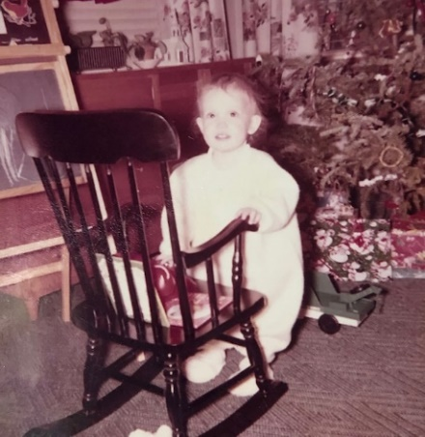 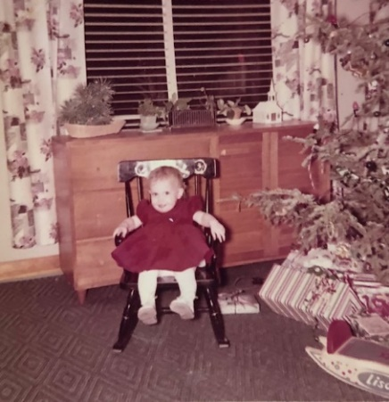

Lisa on Christmas Eve on the left, and Christmas Day on the right.

**12-30-60** **– Alan is born!** He was born at “about 6:05 PM”, weighed 6 lbs 15 oz, and was 20” long.